

LABOR MARKET INFORMATION MANAGEMENT SYSTEM
FOR SOCIAL SERVICES AGENCY -
EMPLOYMENT SUPPORT SERVICES
OF GEORGIA
Concept Paper
Final version released for review 1.0





Revised 25 March, 2016

This Concept Paper was prepared by:

Petr Hortlík, Ivan Majerčák, Illian Pavlov and Robert Zemko

between 02-05/2016

The content of this paper does not reflect the official opinion of the European Union. Responsibility for the information and views expressed in the report therein lies entirely with the Twinning partners.

TABLE OF CONTENT
1 TABLE OF CONTENT 4
2 ABBREVIATIONS 6
3 GLOSSARY 8
4 Executive Summary 12
5 Introduction 13
5.1 Purpose of the document and background 13
5.2 Structure of the document 13
5.3 LMIMS and its benefits 13
5.4 Reference to EU labor market systems 14
6 Assumptions, preconditions and expected issues 16
6.1 Institutional conditions and Institutional Reform Plan (IRP) 16
6.2 Legislative conditions 17
6.3 Relation to strategic IT documents in Georgia 17
6.4 Unification of catalogues/codes and their usage 20
6.5 Implementation assumptions 21
6.6 Licensing Assumptions 21
6.7 Hardware/Infrastructure Assumptions 21
6.8 Training Assumptions 22
6.9 Post-implementation assumptions and expected issues 22
6.9.1 Data migration 22
6.9.2 Support 22
6.9.3 Upgrade procedure 23
7 Agendas and Processes of LMIMS System 24
7.1 Agendas and functions of typical LMIMS 26
7.1.1 Active Labour Market Policies 26
7.1.2 Foreign Citizens 26
7.1.3 Information and Counselling Services 27
7.1.4 Inspection 28
7.1.5 Professional Counselling Services 28
7.1.6 Labour Force Management 29
7.1.7 Private Agencies 31
7.1.8 Sheltered workshops and workplaces 31
7.1.9 Job Vacancies 32
7.1.10 Employers 32
7.1.11 Financial Management of Projects (FMP) 33
7.2 Case Management System within LMIMS 34
7.3 User Administration 35
7.4 Profile Search 35
7.4.1 Job Vacancies searching system 35
7.4.2 Job seekers searching system 36
7.5 Role of calendars in the system 37
7.5.1 LMIMS User’s calendar 37
7.5.2 Client’s calendar 38
7.6 Other components of the solution 39
7.6.1 WebPortal of LMIMS 39
7.6.2 Calling system 40
7.6.3 Documents reader 40
7.6.4 Tablet for signing document 40
7.6.5 eLearning 40
7.7 Integration with external systems 41
7.8 Reporting 42
8 Non-functional requirements 43
8.1 Environments 43
8.2 Communication model 43
8.3 Desktop vs./and Web architecture 43
8.4 Knowledge Management, Collaboration Platform and Project Management 43
8.5 Project Documentation 44
8.6 Security, logging and audit 44
8.7 Scalability, availability, extensibility 45
8.8 Security procedures: Backup and recovery 45
8.9 Trainings 45
9 Principles and architecture of LMIMS 46
9.1 General architecture principles 46
9.2 Authentication 47
9.3 Access Rights 47
9.4 Multichanneling 48
9.4.1 Multichanelling Strategy 52
9.4.2 Characteristics of singular types of channels and their expected using in Georgia 52
Face-to-face services – 53
Online services 54
9.5 Main modules of LMIMS System 56
9.5.1 Core Employment IS 56
9.5.2 Document Management System 56
9.5.3 Economic system (ECIS) 57
9.5.4 Digitalisation and archive of documents 57
9.5.5 Chip Card management 58
9.5.6 Management Information System 59
9.5.7 Statistical Reports 59
9.5.8 WebPortal 59
9.5.9 Social Systems IS 60
9.5.10 Call Center IS 61
9.5.11 Identity and Access Management 61
9.5.12 Datawarehouse & Reporting 62
9.6 Data model 62

ABBREVIATIONS

Abbreviation | Description
ALMMs | Active Labour Market Measures
ALMP | Active Labour Market Programmes
CO | Central Office
CG | Career Guidance
DESS | Department for Employment Support Services
DG EMPL | European Commission Directorate-General for Employment, Social Affairs, Inclusion
ESS | Employment Support Services
EC | Employment Counselling
EU | European Union
EUD | European Union Delegation to Georgia
EUVEGE | Technical Assistance to VET and Employment Reforms in Georgia
IAP | Individual Action Plan
ILO | International Labour Organisation
IRP | Institutional Reform Plan
ISTP.sk | Internetový Sprievodca Trhom Práce - IT System of UPSVaR – self-service portal for jobseekers and employers, comparable in its functionality to WorkNet; part of ISSZ LMIMS
ISSZ | Informačný systém služieb zamestnanosti - LMIMS System of UPSVaR – backend part
ITWG | IT Working Group (of this Twinning Project)
LC | Local Centre
LLG | Lifelong Guidance
LMIS | Labour Market Information/Intelligence System
LMIMS | Labour Market Information Management System of the Public Employment Service (SSA/ESS Worknet)
MoES | Ministry of Education and Science
MoLHSA | Ministry of Labour, Health and Social Affairs
MS SQL | Microsoft SQL Server <version>
NSM | New Service Model
P2P | PES to PES Dialogue, Mutual Learning Programme of the European Public Employment Services
PES | Public Employment Service
PREAs | Private Employment Agencies
RDBMS | Relational Database Management System
RTA | Resident Twining Adviser
RC | Regional Centres
SQL | Structured Query Language used for querying the database
SSA | Social Service Agency
ÚPSVaR | ÚPSVaR – Central Office of Labour, Social Affairs and Family
UI | User Interface
WYSIWYG | What You See Is What You Get

GLOSSARY

- Career Counselling/Guidance focuses on longer-term career goals and is more client-centred in nature. Career Counselling Guidance canbe offered to some unemployed individuals and job-seekers, but may also be offered to students and to employed individuals, or to individuals thinking of returning to the labour market. (EC DG EMPL, P2P Analytical Paper, Borbely-Pecze-Watts, 2011)

- Career Management Skills (CMS) A range of competences which provide structured ways for individuals (and groups) to gather, analyse, synthesise and organise self-educational and occupational information, as well as the skills to make and implement decisions and transitions. (European Lifelong Guidance Policy Network, Glossary, 2014)

- Employer is a legal person based in the territory of Georgia or a physical person with a permanent residence permit in Republic of Georgia, and who employs at least one physical person on working contract or similar type of contracted employment.

- Employment Support Services in Georgia refers to a department of Social Service Agency, called the Department for Employment Programmes, but the title will change into the Department for Employment Support Services (DESS).

- Public Employment Service (PES) should be understood to refer to the national employment service (and regional/local equivalents) together with any other publicly funded bodies whose main responsibility is to facilitate the integration of unemployed and other jobseekers in the labour market. (Eurostat, 2013)

- Registered Unemployed Jobseeker –Registered unemployment figures are administrative data which refer to the number of persons registered as unemployed with the National Registers of the Public Employment Services of each country. The official figure of “registered unemployed” is subject to national rules and definitions specifically linked to each country’s tradition and which differ across countries. (Eurostat, 2006) In Georgia it is a person, who is capable of working, willing to work and is searching for a job, and is at the same time registered in the WorkNet system in the register of jobseekers. Registered unemployed job-seekers and employed job seekers are not yet separated in the WorkNet.

- Registered Employed Jobseeker is a person, who is currently employed, but is looking for another job, and he/she is not in the register of unemployed jobseekers.

- Rehabilitation counselling, which focuses on wider issues relating to help those with special needs or disabilities to gain employment. Rehabilitation counselling may be viewed as a specialisation within career counselling. (EC DG EMPL, P2P Analytical Paper, Borbely-Pecze-Watts, 2011)

- Profiling: the act or process of extrapolating information about a person based on known traits or tendencies <consumer profiling>; specifically: the act of suspecting or targeting a person on the basis of observed characteristics or behavior <racial profiling> (Merriam-Webster Dictionary)

- Disadvantaged jobseekers is a registered jobseeker, who belongs to one of the following categories, e.g.;
- youth under the age of 25
- citizens over the age of 50 years,
- citizens who have been registered in the register of job seekers for more than 12 consecutive months (the long-term unemployed)
- parent returning from maternity leave
- lone parents
- disabled jobseeker
- any other group according the national policy priorities, in Georgia e.g. IDP (Internally Displaced Persons)is a special group
Public priorities and other (item 7.8) refers to any nationally recognised disadvantaged groups notcovered above.

- Employment counselling, which focuses mainly on assessment and on developing and implementing an agreed action plan focused mainly on a pathway for rapid labour market integration. (EC DG EMPL, P2P Analytical Paper, Borbely-Pecze-Watts, 2011)

- Individual case-management services are services of individualised assistance (e.g. intensive counselling and guidance, job-search assistance) and follow-up for unemployed persons provided as part of a planned path towards durable (re-) employment.

- Lifelong Guidance-lifelong learning, guidance refers to a range of activities that enables citizens of any age and at any point in their lives to identify their capacities, competences and interests, to make educational, training and occupational decisions and to manage their individual life paths in learning, work and other settings in which these capacities and competences are learned and/or used. (Draft Resolution of the Council and of the representatives of the Member States meeting within the Council on Strengthening Policies, Systems and Practices in the field of Guidance throughout life in Europe, 8448/04 EDUC)

- Unemployed (Labour Force Survey) - In accordance with the ILO standards adopted by the 13th and 14th International Conference of Labour Statisticians (ICLS), for the purposes of the Community labour force sample survey, unemployed persons comprise persons aged 15 to 74 who were:
- without work during the reference week, i.e. neither had a job nor were at work (for one hour or more) in paid employment or self-employment;
- currently available for work, i.e. were available for paid employment or self-employment before the end of the two weeks following the reference week;
- actively seeking work, i.e. had taken specific c steps in the four week period ending with the reference week to seek paid employment or self-employment or who found a job to start later, i.e. within a period of at most three months (Eurostat, 2006). In Georgia,the GEOSTAT is responsible for this measurement;however a full scale Labour Force Survey was not yet introduced in the country. GEOSTAT has been using a module within the Household Survey to measure statistical unemployment.

- Services refer to labour market interventions where the main activity of participants is job-search related and where participation usually does not result in a change of labour market status (Eurostat, 2013).

- Measures refer to labour market interventions where the main activity of participants is other than job-search related and where participation usually results in a change in labour market status. An activity that does not result in a change of labour market status may still be considered as a measure if the intervention fulfils the following criteria: - the activities undertaken are not job-search related, are supervised and constitute a full-time or significant part-time activity of participants during a significant period of time, and - the aim is to improve the vocational qualifications of participants, or - the intervention provides incentives to take-up or to provide employment (including self-employment). (Eurostat, 2013) In Georgia currently different ministries are responsible for different measures, Social Services Agency / Employment Support Services has no comprehensive information on these.

- Voucher is a bond of the redeemable transaction type which is worth a certain monetary value and which may be spent only for specific reasons or on specific measures.

- Labour demand reporting form is a hard copy document that is handed to a registered jobseeker by his/her job mediator when registered jobseeker is sent for interview to an employer. Employer confirms in this document attendance of registered jobseeker at interview and marks outcome of interview.

- Apparatus is a Department of Secretariat for Director General of Social Service Agency

Executive Summary
Following are the main points and findings that define this Concept Paper and its future use:
- This Concept Paper as well as the following document – Terms of Reference are templates for the future procurement of LMIMS. It is not known, what the procurement setup will be or what funding options will be available and what the extent of the project will be. Therefore, this paper can be used freely by the Beneficiary: chapters (especially about agendas and processes) can be added or removed and the functionality modified according to legislation and other conditions in Georgia and at MoLHSA at the time of procurement.
- Recently, there were significant improvements of the Worknet system, which is operated by SSA. The main upgrade of WorkNet has been done in 2016 and new functionalities of this web portal solution were added especially for employers and vacancies they provide. We see a very good potential of this web portal solution for providing online services to clients after anticipated integration with LMIMS system which is necessary to implement for providing support for SSA staff and for significant improvement of efficiency of SSA services. Worknet can be the „face of SSA to clients“, once it becomes part of LMIMS. Currently, the WorkNet has no features prepared for any backoffice support (functionality/management/KPIs/advanced agendas), including the assessment of the quality of service of the offices. This is not worrying situation because the architecture of the system and targeting of this system was not oriented as a backoffice system.
- For covering needs of SSA and Labour Market, a new LMIMS should be introduced in Georgia’s SSA, to cover the agendas mentioned in Chapter 7 as well as complex reporting on labor market state and KPIs of the offices on all levels.
- The new LMIMS should be supported by new legislation, as many processes are missing or not in line with European standards legislation.
- The future LMIMS is by several orders of magnitude bigger system than WorkNet (Worknet is consider to be one of 11 components (see Figure 1 Simplified scheme common modules of LMIMSs in Slovakia, Czech Republic, Hungary). Therefore, following things are expected to be ensured:
  - Personal support
  - Legislation support
  - Financial support for both development and operations
- On the road to LMIMS, following scenarios seem to be the most realistic ones:
  - Constant upgrade of WorkNet until it caters for basic needs of not only SSA clients but also employees at local, regional and national level.
  - Introduction of the LMIMS with full functionality, including the frontend portal by development from scratch or by purchasing of the existing solution and its modification.
  - Alternatively, to previous point, WorkNet can be kept as a front end portal and the LMIMS can cover only backend functionality. This would lower the expenses required for building the complex solution.
- Of these scenarios, the authors of the document recommend the latter two to be considered when procuring the new LMIMS system.

Introduction

Purpose of the document and background
The object of this Concept Paper is to define the main agendas, processes, architectural decisions, implementation and post-implementation requirements leading to a creation of a system with full LMIMS functionality operational in the Georgian environment.

The labor market services provided by SSA are currently supported by a bespoke application WorkNet which was originally developed around 2012. In 2016, SSA has added modules, which allow employers and vacancies to be registered leading to a governmental job portal similar to commercial solutions.

While the current version of the WorkNet system has addressed the immediate needs of the SSA for providing the registration of employers, jobseekers, vacancies and their matching, it is understood by both Twinning team and the SSA counterparts, that serious gaps in functionality exist between standard LMIMSs and WorkNet. To mention only the most critical one – the whole backoffice functionality of such system is missing, providing to means for the SSA employees to enter the system, work with the data (otherwise than through Excel proxy) and to plan and organize their daily work of mediation, conselling and in conclusion to filling in the vacancies.

This document might be used as a basis for the public procurement in the future, once enough resources are collected to implement the solution in its full scope. Although the constant upgrade path from current solution (WorkNet) is possible, it is not recommended by the authors of this document. It might lead to a series of small improvements instead of one great leap forward.

Also, another development path from the current state is possible – it is the one that took countries like Czech and Slovak Republics. Once a new legislation is introduced to support most of the processes described in the chapter 7, WorkNet might undergo a major update, while a new system is introduced for the backoffice, leading to the full LMIMS functionality on both frontend and backend.

Structure of the document
The main chapters of this document are 6, 7 and 8. While Chapter 6 describes assumptions, which were made when writing this paper and also which must be fulfilled before the system is ready, Chapter 7 describes the agendas, business processes and functions, which are usually covered by LMIMS in EU. This chapter is based on the experience with ISSZ system in Slovak Republic and similar systems in Czech Republic and Hungary. This chapter is strictly written in business language (can be considered as high-level requirements specification) and contains no technical or implementation details and is therefore suitable to be reviewed by business users and power-users/analysts from PES/SSA.

Chapter 8 describes the non-functional requirements (NFRs) for LMIMS system, which are similar to the requirements of not only LMIMS systems, but many bespoke back-end systems. In this chapter we are trying to point out the specifics of the LMIMS systems while not neglecting the changes from NFR of WorkNet to NFRs of a sophisticated future LMIMS.

LMIMS and its benefits
Labour market information and management system represents (LMIMSs) represents a key instrument for provision of employment services in Georgia and elsewhere. In its full meaning it not only covers needs of external target groups in job mediation process through WorkNet portal but the automation of the whole management of Employment Support Services.

Well designed LMIMS in ESS aims to ensure a single, centralized system of employment services for central, regional and local offices providing following benefits:
- Sufficient information about labor market requirements.
- Reliable and accurate data.
- Sufficient information about target group (jobseekers, employers, training providers, agencies, other).
- Interconnect central, regional and local ESS offices and ensure access of data regardless of location.
- Standardize processes, methodologies, activities, catalogues and documents.
- Central database/data warehouse for reporting and statistics.
- Appropriate targeting using multichannel to eliminate extra burden of ESS offices resulting from paper documents and excel files.
- Automate management and everyday activities of the ESS.
- Be in line with national e-government strategy and standards.
- Support legislation changes (economic variables, ALMPs etc.).
Further in this document authors are elaborating concept which is considering the current status of the WorkNet up-to March 2016 and replacing it with the wider Labor Market Information Management System covering all aspects mentioned above.

Reference to EU labor market systems
Labor market information and management systems in Europe might vary in different countries in certain functionalities (mostly dependent on the historical evolvement of the institutions, their agendas and processes) however all of them aim to provide comprehensive employment services linking employers and jobseekers and provide management of standard agendas falling into scope of organization activities (see Figure 1 Simplified scheme common modules of LMIMSs in Slovakia, Czech Republic, Hungary).

In most cases, LMIMS consists of its Frontend part which is "customer oriented" (employers and employees/jobseekers/unemployed, trainers, agencies) and supports job mediation online using multichanneling to ensure reach to every potential client. Backend part is simplifying and automating standard agendas and processes falling into scope of the Employment Support Service while providing necessary KPIs to track the quality of service of the agency.

On top of the Frontend and Backend, reporting and business intelligence (BI) tools provide reports for comprehensive overview of the labor market and organization management.

In many countries, because of historical reasons and often humble start of the LMIMSs, many compromises can be seen. Frontend and backend systems are often connected only by the means of data data exchange (ETL – extract, transform, load), sometimes the architecture is inconsistent because many years have passed between the implementation of first and last module.

This can be considered as an opportunity for Georgia to build/purchase the best and most consistent system suiting its needs. The system, despite certain effort invested into WorkNet, will be built from scratch (with expected data migration from WorkNet system), which allows for clean implementation with no heritage and no strings attached.

Figure 1 Simplified scheme common modules of LMIMSs in Slovakia, Czech Republic, Hungary

Assumptions, preconditions and expected issues
In this chapter, assumptions that were made prior this Concept Paper was prepared, assumptions/preconditions that must be met before implementation and assumptions/expected issues that must follow the implementation are summarized.

Institutional conditions and Institutional Reform Plan (IRP)
Of the many assumptions which must be fulfilled before the development of a LMIMS system in Georgia, the Institutional Reform Plan (IRP) is one of the most important ones.

Once implemented, the IRP will introduce new services in the day-to-day work of SSA employees. Namely, following services will require almost immediate IT support:
- Registration (in the WorkNet)
- Profiling – segmentation of the jobseekers into categories based on the range of support and services they might need to get employed
- Information
  - about work with WorkNet
  - about the SSA services/ALLMs
  - about the rights and obligations
  - about suitable vacancies
- Job mediation services
  - Job matching
  - Referring client to self-service and online tools
  - Inviting clients to selection procedure-interviews
  - Managing return of labour demand reporting form
- Employment Counselling
  - Individual counselling
  - Group counselling
  - Individual Action Plan (IAP)
- Referral into ALMMs
Although some of the services exist in various forms today, they are either limited in their scope or not done properly.

For example, the registration process through WorkNet allows jobseekers to register and even to synchronize their data against civil register, but there is no interface for the SSA employee to register the jobseeker in any other way than to ask for his ID and then do the registration through the same interface, as the jobseeker would do it. There is also no possibility of validation of the data entered – e.g. to confirm that the jobseeker is a holder of diploma, certificate, certain level of education or any other relevant document. It turns out to be very helpful for the employers, to be able to search through validated profiles and it is one of the added values of government portals in comparison with commercial ones.

For the reference on how the IRP will be piloted and executed, pls. refer to manuals. The IRP does not rely on a functional LMIMS, but mostly caters on what exists today. Several changes described in other documents were proposed, but their implementation is uncertain and they will bring only temporary relief to the new system of the work. Although WorkNet is in place, several agendas and processes will be executed using old fashioned physical files, physical forms and manual exchange of these. Because the data will be in on paper or at the best – in Excel files, it will again not be possible to work efficiently in terms of mass addressing of the issues (e.g. selecting profiles falling into one of the challenged groups III-IV), precise filtering, integral migration of the people and also in terms of monitoring of the staff efficiency through KPIs. All this can be addressed only through the LMIMS which operates on the back office side as well.

The currently presented IRP, once it goes live, will surely advocate for the new LMIMS. The SSA staff will sooner or later create a demand for such a system, once they discover the limitations of the current solution.

Once the new LMIMS is in place, a new IRP will have to be prepared as part of the methodology of new business processes.

Legislative conditions
As it is already mentioned in the Functional Review document, elaborated by the Twinning Team, there is a clear need for a legislation reform in Georgia:
Ensure clear legal framework on employment policy implementation, which implies elaboration of a Law on employment support services stipulating main definitions and parties involved in the employment policy in line with the EU standards for Public Employment Services. The clients of employment support services should be clearly defined and distinction between job seekers and unemployed persons made. Entry criteria for registration of unemployed persons (in the Worknet) need to be defined as well as obligations and rights unemployed and job seekers, including access to active labour market measures. This recommendation is in line with the Constitution of Georgia, Article 32 according to which “The State shall promote helping the unemployed find work. Conditions for ensuring some minimum standard of living and status for the unemployed shall be determined by law”.

Although there are no legislation changes foreseen in the near future, especially the Labour Act seems to be far away, certain changes will have to take place, either as part of IRP or as small amendments to the existing legal framework.

One of the main assumptions in this document is that the SSA will be able to distinguish in its systems and also while approaching its customers between the unemployed and jobseekers and of the unemployed to be able to categorize them according to their special needs and conditions. LMIMS should by no means be closed system for unemployed only, jobseekers should be served by the same system, but with respect to the rights (and obligations) of the unemployed.

Relation to strategic IT documents in Georgia
During the course of our mission, several important documents were identified relating to the overall government IT environment in Georgia:

- e-Georgia strategy and action plan 2014-2018 http://dea.gov.ge/uploads/20130706%20eGeorgia_%20final_DRAFT%20for%20public%20consultation.pdf)
- Open Government Partnership Action Plan 2014 – 2015 Georgia (http://www.opengovpartnership.org/sites/default/files/OGP%20AP%20GEORGIA.pdf)
- DataExchange Agency Law
- Law of Georgia on Personal Data Protection
- Georgian Law On Amendments and Additions in General Administrative Code of Georgia
- E-GOVERNANCE AND E-TRANSPARENCY – INTERNATIONAL TENDENCIES AND GEORGIA https://idfi.ge/public/migrated/uploadedFiles/files/Chapter%20I%20eng.pdf
- Decree N775 of July 9, 2013 on Necessary Measures for Implementation of the Open Government Partnership Action Plan of Georgia

This document is trying in all its aspects be in full compliance with these documents, although some of them are drafts/working versions or can be only considered as visionary documents. We see high urgency of an efficient usage of various Governmental resources and cooperation between relevant technological platforms to lower the implementation costs of the future solution and to be interoperable with other prepared solutions.

Following is the diagram illustrating the main priorities in the development of Georgian IT in the following years (the strategy is set for period of 2014-2018):
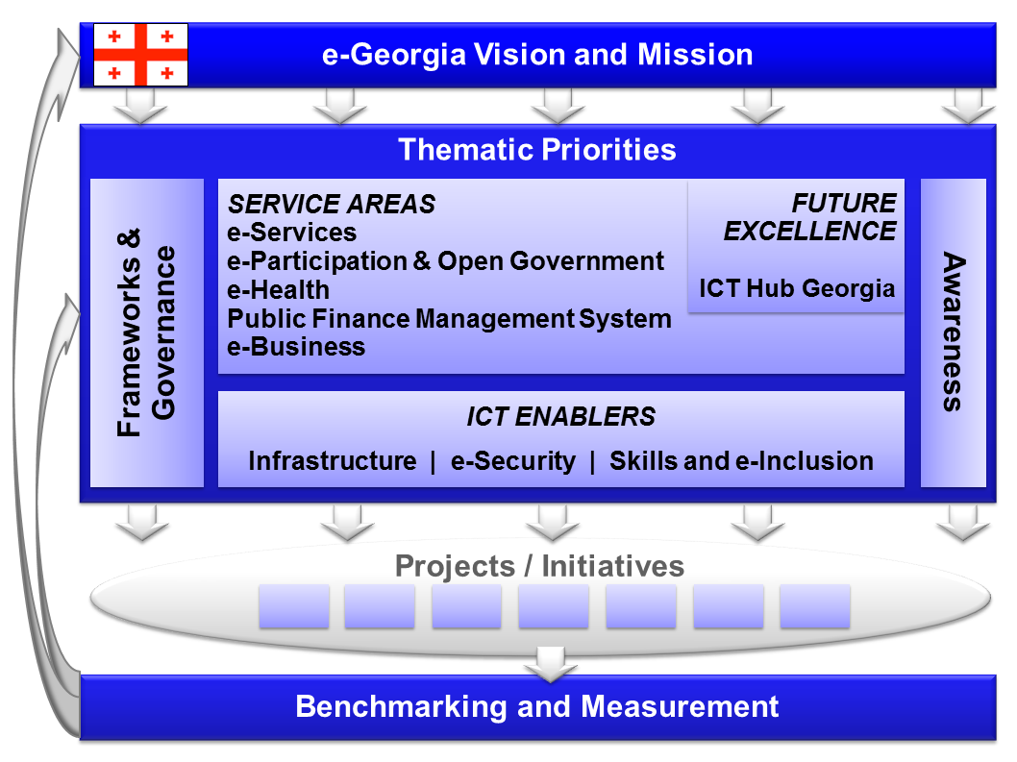

The most notable for this paper are the following:
Thematic priority | Description
e-Services | To capitalise on the potential of ICT and to optimise the efficiency and effectiveness gains of investments, Georgia must concentrate its efforts on ensuring the availability (i.e. supply) and use (i.e. demand and take-up) of online public services by government, businesses and citizens.  Working with stakeholders from different target groups (i.e. government, businesses, citizens, and non-governmental and interest organisations), the “service” track of the e-Georgia strategy therefore focuses on the supply of G2C, G2B/B2G, G2NGO and G2G services.
e-Health | Every citizen can benefit from e-Health services. Hence, innovative e-Health services will be a key success factor. A “Georgia Health Management Information System Strategy” was already developed by the Ministry of Labour, Health and Social Affairs in 2011. The e-Health action plan is a vital part of the e-Georgia strategy. A comprehensive Health Management Information System (HMIS) will be built upon existing international standards.
Public Finance Management System | The Public Finance Management System (PFMS) consists of a number of sub-systems, each tackling a specific purpose for public finance management: e-Budget enables digital budget planning and reporting to the Ministry of Finance; e-Treasury helps recoding and managing spending; e-DMS, the electronic Debt Management System is for international debt management and internal loan management; e-HRMS – electronic Human Resource Management System supports human resource management in government agencies; RS.GE - for collecting tax and customs revenues; e-Procurement – for public tendering and electronic procurement of goods, services and works by the procuring entities as set by the PPL (Public Procurement Law); e-Auction - facilitating the selling of State-owned goods to private and civic sectors. The PFMS has become an important pillar for G2G and G2B modernisation and management of planning, collecting and spending of public finances, debts and any other assets the government has to manage.
Infrastructure | An e-Society needs basic infrastructure elements as a prerequisite for the take-up and innovation in thematic priorities of service areas and of future excellence. This includes especially access to the Internet but also basic services like identification / authentication as well as back office granular and aggregated services, which act as a multiplier layer for the provisioning of online services in prioritised service areas.
Skills and e-Inclusion | The Georgian people can only exploit the potential of ICT if they know how to use and develop these new technologies. In education, a clear view on how to ensure that the next generation will have the skills to manage the new technologies is necessary. For improving the e-Skills of the general population, several measures are to be taken. Also attention needs to be given to special target groups like the elderly, disadvantaged, low-income people or people living in rural areas. Another focus point to be resolved is the gap between ICT curricula and businesses’ needs for ICT skills. Students and businesses only profit from profound modern ICT education if what they learn matches the needs of the professional ICT sector.
Enabling frameworks and governance | Successful implementation of an e-Georgia strategy requires the setting up of proper organisational structures such as a legal framework enabling electronic interaction and service provision, and ensuring that digital transactions have the same legal status as traditional procedures. A proper interoperability (or IOP) framework ensures smooth interaction among the actors in an e-Society to exploit the full potential of innovative ICTs. An Enterprise Architecture framework provides guidelines for how to successfully develop e-Services and ICT enablers (infrastructure, security, universal services, etc.) for different stakeholders. Good Governance and Open Government principles provide guidelines for e-Georgia. Ensuring the effective and efficient implementation of an e-Georgia strategy and the continued planning and discussion of the future directions of a Digital Georgia, requires working together and establishing a common coordination instrument. Community building is another aspect key to innovative developments of solutions, which need to be enabled.

Not very surprisingly, the accent is put on e-Services, enabling the citizens to use as many self-serviced services as possible. In the second place, there is the eHealth system, which should be implemented on the same ministry as LMIMS. Therefore, and because of foreseeable data overlap, the development of these systems should be carefully coordinated.

Of the remaining – judging from the interview on the Data Exchange Agency, it is not expected, that there will be government cloud anytime soon in Georgia, therefore the infrastructure is fully in hands of MoLHSA, which basically allows for any platform and requires (quite strictly) integration through service bus (no data pumps, ETL etc.).

Unification of catalogues/codes and their usage
It is recommended, to the greatest possible extent to use standardized catalogues and code tables (lookup values) in LMIMS. These catalogues should (where it is possible) be identical with:
- European catalogues/codes (http://ec.europa.eu/eurostat) in given field
- National Georgian catalogues/codes (http://geostat.ge/index.php) in given field

In the cases where SSA makes definition of their own (i.e. SSA is the primary source of the catalogue), catalogues/codes should be extensively promoted to other institutions through easy-to-access data exchange interfaces or even SSA web page. These catalogues/codes for other cooperating institutions and SSA should ensure adoption of these catalogues/codes as the official catalogues/codes on the national level.
Following is the basic set of catalogues/codes (some of them are implemented already in Worknet System):
- C_Language
- C_Branches (Transportation, Finance, IT, …)
- C_School_subjects (Mathematics, Biology, …)
- C_JV_visibility (JV visible on: Labour Office, Internet, …)
- C_School_Languages (list of Languages which are available in educational system)
- C_Shifts (1 shift, 2 shifts, 3 shifts work…)
- C_Salary_paid (Daily, Weekly, Monthly, ...)
- C_Shool_Ownership (Governmental, Charity, …)
- C_Graduation_Studies (Graduate certificate, Certificate, …)
- C_Langauge_Knowledge (Excellent, Very Good, …)
- C_Benefits (Benefits provided by employers – Free meal, Accommodation…)
- C_Level_of_Education (University, High school, …)
- C_ISCO08 (http://geostat.ge/index.php?action=page&p_id=977&lang=eng )
- C_NACE
- C_KKOV
- C_KZAM
- C_Skills (PC, Economics, …)
- C_Regions (list of Georgian regions)
- C_ISCED (International Standard Classification of Education - ISCED-2011- http://geostat.ge/index.php?action=page&p_id=977&lang=eng)
The LMIMS should also use catalogue/projects on European level which can deliver know-how on employment matter which should be implemented in LMIMS (project ESCO, https://ec.europa.eu/esco/portal/home ).

Implementation assumptions
The LMIMS project feasibility, baseline, costing and other parameters, presented in this document or in the (next in line document) Terms of Reference document are based on the accuracy of the following assumptions. If these assumptions are invalid for any reason, the timeline and effort will have to be reassessed and will follow standard change procedure valid for procurement or implementation.

Licensing Assumptions
There is no technology and/or platform suggested for the future solution, mainly because:
- It cannot be foreseen, when the implementation will take place.
- There are no out-of-box solutions for the LMIMS systems. Although there are certain modules for portal platforms like DNN, SharePoint, Liferay etc. these platforms cannot be suggested, because they usually cover only the jobseekers, employers, vacancies and few more features. Their implementation would require deep rework and it is questionable, if this would be feasible.
- The Georgian institutions are free to tender or decide which technology fits best their environment, however there are limitations on the institutional level, resulting from training of the operations and development staff.
- If the LMIMS solution is to be implemented, it is advisable to consider reuse of functional existing systems (EU) based on the same principles, modules and agendas as presented. Obviously, the purchase of the LMIMS cannot be perceived as installation and configuration only, the development in such a case is inevitable.
- For the implementation of the back-office functionality, a case management platform should be considered, as many of the processes are cases, workflows and work queues in their nature.
- The licenses are generally purchased by Georgian institutions, which have framework contracts with the main suppliers.

Hardware/Infrastructure Assumptions
Based on the current situation, following HW/Infrastructure assumptions can be made:
- The system will be hosted within the MoLHSA data center in Tbilisi
- The system infrastructure will be managed by MoLHSA
- The infrastructure of the current system WorkNet will be fully replaced by the new system, whether or not it is built on its foundations. The WorkNet infrastructure has not been upgraded significantly during the last years (since its deployment in 2012) and the product set it is built on is aging beyond the point of supportability.
- Another reason for WorkNet infrastructure replacement is its insufficient capacity to support both back office system and its web front end. The new infrastructure must allow for no single point-of-failure and scale up/out possibilities.
- Network connectivity for the regional offices is in place although its parameters are unknown. Generally, Internet coverage in the bigger cities of Georgia is good (dozens of providers with ADSL/DSL/Cable options) and the 3G/LTE coverage and prices are also comparable or lower than in other European countries. The government of Georgia has a contract with a selected mobile operator providing voice and high speed data (in urban areas) to the selected employees at very low prices. Therefore, also mobile workplaces can be considered for the cities, towns and vicinities.
- However, if the solution allowing for in-the-field data collection will be considered, a research should be done on the 3G/LTE coverage of the country and possibly a Message Queuing solution with off-line capabilities should be considered in first place.
- The network security features are generally purchased centrally, for the whole MoLHSA.

Training Assumptions
Based on the current situation, following Training assumptions can be made:
- It is highly recommended, that the initial training of the system takes the train the trainer approach.
- A lasting capacity of the trainers must be built before the go-live of the project.
- Advanced trainers can also act as methodologists on the regional and central level for everyday support as well as further development.
- Training delivery and all training materials must be provided in Georgian only.

Post-implementation assumptions and expected issues

Data migration
Although data migration was a big issue in the LMIMS systems implemented in Slovakia, Czech Republic, Hungary etc., it will probably be a (comparably) minor issue in the Georgian environment. It is mainly because except of WorkNet, there is no official system implemented or running on the branch offices. Also, WorkNet contains rather limited set of data and there is no requirement for the business continuity, so the data migration can be done in a service window spanning several hours or days at most.

However, the data migration should not be underestimated. The main issues that can be foreseen are following:
- Data migration from external systems – although the official strategy of MoLHSA is “use web services, ask for individual records”, certain registers/codes/lookup values must be migrated and kept synchronized within the new LMIMS system.
- Data cleansing must be done before it enters the new LMIMS system. Although some parts of database were cleaned during the upgrade in 2016, integration with the registers and introduction of new lookup values will lead to an extensive data scrubbing.

Support
Based on the experience from the Slovak system ISSZ, the project requires fully operational support from the first day of go-live (but trained long before). This support mainly includes:
- Support of the operations – the system must be available 24x7, therefore the operations department must consider it as a priority system with up to 99.999% uptime.
- Data validation service – at least 5x8 or preferably 7x12 (24?) hour service of supporting staff, that can validate incoming requests (mainly the registrations of employers and vacancies) and can vet the improper ones (double identity of a business, discriminating conditions stated in the vacancy description etc.). This service can be both outsourced or in-house. In case of outsourcing, the service must have a close connection to SSA (legislation and methodology unit) for resolving complicated problems. Also, it is highly recommended that this service works in a limited scope also during the weekends, because the web site operates 24x7 and the waiting period for the information to be published should not be 2 days.
- Help Desk – preferably 24x7 for handling technical problems like lost password, technical problems in various browsers etc. as well as business processes problems. Perhaps, the existing call center at MoLHSA can be extended for such purposes.
- Internal Help Desk – priority service for SSA employees from branch offices, not only solving technical problems but also advising on methodology and system use.

Upgrade procedure
Because of the nature of the business processes (they might be long-running), the upgrade procedure for change requests/fixes/etc. must respect data continuity and operations continuity. The service windows should be carefully planned outside of working hours of the branch offices. The upgrades are expected to be quite frequent, based on legislation changes, new ALMPs etc.

Agendas and Processes of LMIMS System
In the following chapter, main agendas, processes and functions of typical LMIMS are described. This chapter is based on the best practices from Slovak, Czech, Hungarian and other systems, that are currently operational in EU countries. The list of agendas and processes is intentionally broader than a single country-level LMIMS, to guide the reader through potential areas, that might be covered by the LMIMS during its implementation and in further iterations.

Basically, following are the areas covered by LMIMSs in all the previosly mentioned countries:

Figure 1. Standard Agendas covered by LMIMS (PES) System

Following areas are further discussed in the following chapters. At the same time, the agendas/areas can be reflected during the development of the system in the logical modules of the system, working above the same database, because of overlapping nature of the records:

- ALMP - Active Labour Market Policy
  - Support for creation and keeping JV – for Employers
  - Services for clients - forms of aid, contributions and benefits to the citizen
    - Education allowance
    - Support for business
    - Practise for Schoolleavers
    - Activating activity, maintain Jonseekers work habits
    - Grants for persons with disabilities
    - Allowances for CHD / CHP ( sheltered employment for disabled persons)
    - Financial support for mobility (travel, relocation)
  - Statement of Labour market policy allowances
- Foreigners
  - Blue card Record Keeping
  - Foreigners Employment Record Keeping
  - Foreign Employment Permissions
- Information Counselling Centres
  - Informative counselling
    - For Jobseekers
    - For Employers
    - For Schools and school students
    - For Job
  - Preventive counselling
  - Group consultancy - internal
  - Group consultancy – external
  - Inspections
  - Internal Inspections
  - Inspections of Illegal Employment Foreigners
- Professional Counselling Centres
  - Individual professional counselling for Jobseekers
  - Group professional consultancy - internal
  - Group professional consultancy – external
- Professional Centre
- Process of Registering jobseekers
  - Mediation for jobseekers
  - Deregistration of JobSeeker
  - Mediation for Jobseeker in the place of temporary residence
- Permits
- for ADZ - temporary employment agencies
- for APZ - supported employment agency
- for CHD / CHP - sheltered workshops and workplaces
- for Social enterprises
- Paid mediation
- Job Vaccancies
- Registering of Job vacancies
- Competitions

- Employers
      - Job Fairs
      - Exchange of information
      - Massive dismissals
      - Cooperation with employers

Agendas and functions of typical LMIMS

Active Labour Market Policies

Support of the creation and sustainability of the work places (employers)
This functionality of LMIMS covers:
- Subsidies for creation and sustainability of the workplaces by the employers (e.g. contributions to cost of labous, cost of equipment, transport of the employees, training schemes, public work etc.)

Services for clients – forms of subsidies and compensations
This functionality of LMIMS covers:
- Subsidies for training and education – direct subsidies to cover training costs or coverage of the expenses related to training (transport, meals, accomodation)
- Support of the enterpreneurship – subsidies for business initiation (with special conditions for the challenged owners of the businesses)
- Graduate trainings – regular subsidies for jobseekers attending gradate trainings
- Employment activation - work and life skills sustainability - regular subsidies for jobseekers listed for voluntary activation services
- Compensation of persons with disabilities
- Subsidies for shelter workshops/workplaces
- Subsidies for the creation of new jobs, where the occupation will be provided for JobSeekers or for supporting existing jobs which are occupied by the employees.
- Support for mobility (travel costs, relocation subsidies)
- Compensation settlement (travel costs, food allowance, accommodation) associated with searching jobs, with the provision of technical advisory services and so on.
- Contribution for commuting
- Contribution for promoting labour mobility (change of residence or temporary residence)
- Transportation subsidy – it is provided to employer for employees' transportation to workplace (it is provided to employer, not a citizen)

Settlement of contributions for active labor market policy
Payment of individual contributions - to employers, citizens, jobseekers.

Foreign Citizens
Record keping of the Georgian equivalent of the “Blue Card”. The Blue Card is an approved EU-wide work permit (Council Directive 2009/50/EC) allowing high-skilled non-EU citizens to work and live in any country within the European Union, excluding Denmark, Ireland and the United Kingdom, which are not subject to the proposal. The term Blue Card was coined by the think tank Bruegel, inspired by the United States' Green Card and making reference to the European flag.

The Blue Card offers a one-track procedure for non-EU citizens to apply for a work permit, which would be valid for up to three-years, but can be renewed thereafter. Those who are granted a blue card will be given a series of rights, such as favourable family reunification rules. The proposal also encourages geographic mobility within the EU, between different member states, for those who have been granted a blue card.

On the basis of the declared job vacancy (JV) which fulfill the requirements of the highly qualified employment:
- Wage proposed for the vacancy must be at least multiple (given by law) of the average monthly salary in the economy of the Georgia in the relevant sector,
- Higher education is required with limited possibilities for highly qualified workers to participate
- Work contract period is at least 1 year,

Labour offices carry out an investigation of the labor market. The investigation answers the question if for reported job vacancy there can be found in the register of job seekers suitable person(s) and based on that, the central office issues the approval or disapproval with its filling (on Request of the Police). Based on the approval of central office of PES the permit for a citizen from a third country can be issued.

A similar process doesn’t exist in Georgia at the moment, but can be expected due to a rising number of migrants in the recent years. The issuing of the citizenship with all the obstacles, that can be foreseen might not be an option for many of the cases.

Record keeping of employment of foreigners
Record keeping of an employment relationship and the deployment of citizens from countries where an agreement exists between Georgia and such country about employment. For such countries only a reporting obligation on the information card might exist. No permit is issued, but the information is recorded for statistical or inquiry by third party institutions purposes.

Work permit for Foreigners
Labour office issues the confirmation about possibility to fulfill job vacancy. This confirmation is issued on demand of Police and it is base for issuing the temporary residence permit with the goal of employment. The employer is obliged for the job vacancy defined in Employment Law to announce such job vacancy to Labour Office and labour market survey is made.

In some cases, Labour Office can issue to Employer confirmation concerning possibility to fulfill job vacancy by foreigner and issue work permit without Labour Market survey.

Information and Counselling Services
Information and Counselling Services are provided in process of:
- career guidance and choice
- employment choice, including employment transitions
- employee selection
- adaptation of the employee in his new job.

Information and counselling services includes also the services in providing information on:
- requirements for professional skills and practical experience necessary for performing work activities on jobs in the labor market according to the National system of occupations (NSP)
- employment opportunities in Georgia and abroad
- prerequisites for the job
- possibilities and conditions for participation in active labor market measures and activation activities
- conditions for entitlement to unemployment benefits
- conditions for participation in partnerships established with the goal to promote the development of employment within the territorial jurisdiction of the Labour Office.

Information and counselling services are divided into:
- Information Consulting
- Preventive counseling
- Group counseling - internal
- Group counseling - external

Information and counselling services are provided for:
- Jobseekers
- Employers
- School students
- Persons interested in work

The councelling services require an implementation of the National occupation catalogue based on NACE and ISCO standards.

Inspection

Internal inspections
Record keeping of the inspections carried out by Inspection Department of Labour Office or Central Labour Office. The inspection covers all the departments of the competent authority or head offices and organizations that fall within the PES headquarters - children's homes, ….

Compliance with laws and internal rules and procedures as well as management of the funds is being checked and the records are kept within the system to indicate the outcomes (especially negative) when the subject is dealt with (e.g. when deciding about ALMPs).

Illegal Employment Inspections
The inspection is aimed at detecting undeclared work and violation of the laws in the area of labour (existence of employment contract, agreements on work performance, payments employee compulsory insurance - Social Insurance Agency).

Professional Counselling Services
Professional consulting services are aimed at influencing the selection and behavior of jobseekers, creating consistency between the personal qualities of jobseekers and demands of Employers, social and working adaptation of jobseekers:
- Looking and assessment of personal qualities and abilities of the jobseekers and evaluation of their competence,
- Drawing up an individual action plan to promote the employment for disadvantaged jobseekers
- Diagnosis and identification of barriers of entry on the labour market,
- Creating a personality profile of jobseekers to identify activities, measures and services needed for its inclusion into the labor market.

Forms of professional counseling services:
- Individual professional councelling for jobseekers, people interested in employment
- Group expert advice - internal
- Group expert advice - external

Labour Force Management

Jobseekers registering
- Decisions on the inclusion or non-inclusion in the register of jobseekers.

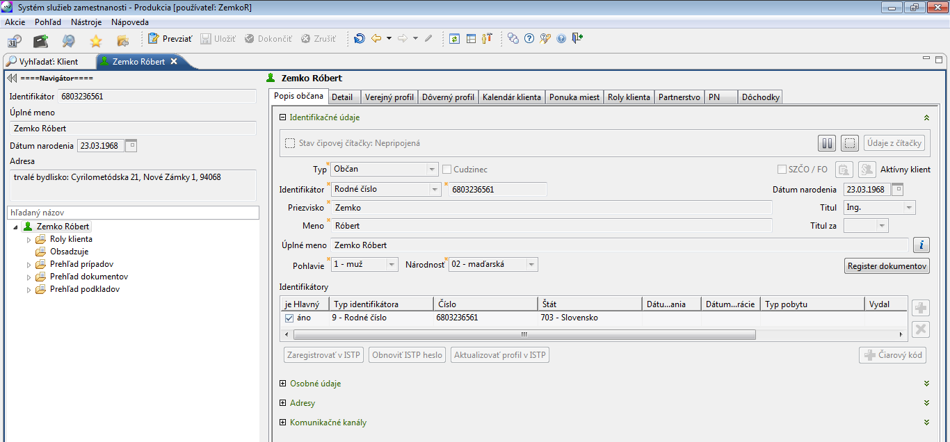

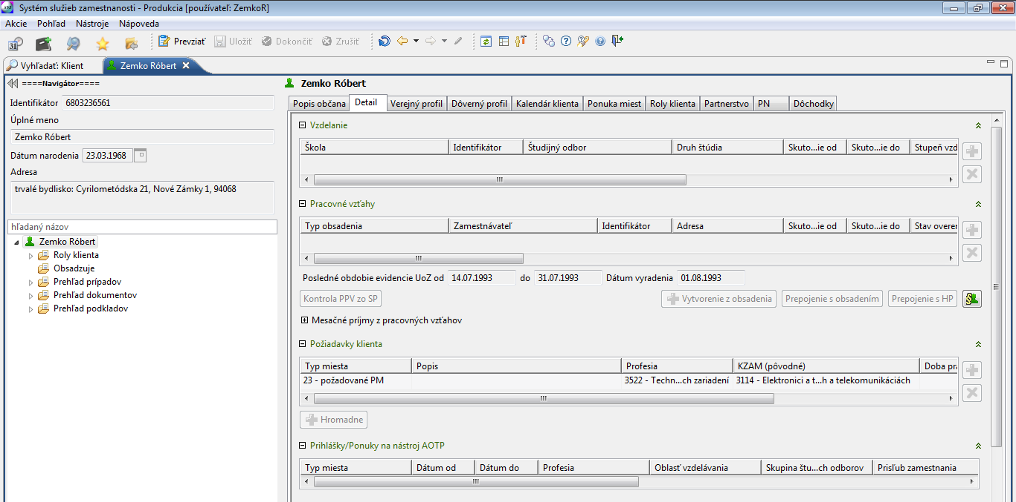
Figure 2 Typical screens for recording data about citizen
(Personal data, Detail of education, employment, special requests)

Mediation for jobseekers
Mediation activity is focused on:
- Job search and offering appropriate employment for jobseekers, people interested in employment and residents in the territory of Georgia and in the future, of the EU,
- Finding suitable employees and introducing them to the selected employer.

Mediation include also:
- Registration activities
- Information and advisory services,
- Ensuring monitoring and evaluation of the employers’ demand for employees - qualification structure and professional structure,
- Evaluation of qualification and occupational structure of job seekers and qualification structure and occupational structure of people interested in employment with regard to the demand of employers.
- Monitoring the time period when the employee stays in employment (for at least six months after his recruitment from the register of jobseekers through one of the active labor market measures).

Figure 3 To-be employment mediation process

Deregistering of Jobseekers
Decisions on removing the jobseekers from the register.

Private Agencies

Temporary Employment Agencies
Agenda of non-governmental (commercial) employment service providers.

Central office can:
- issue a permit to operate for temporary employment agencies,
- decide to change, suspend or cancel the activities of temporary employment agencies.

Temporary employment agencies are required to submit each year annual reports to the central office of PES. If temporary employment agencies do not fulfill this demand central office may revoke their authorization. The new authorization may be requested after three years’ period. Temporary employment agencies employ agency workers who are temporarily assigned to the end employer for the period of their contract.

Supported Employment Agencies
Agenda of non-governmental employment service providers.

Central office can:
- issue a permit to operate for Supported Employment Agencies
- decide to change, suspend or cancel of activities Supported Employment Agencies
Temporary employment agencies are required to submit each year annual reports to the central office of PES. If temporary employment agencies do not fulfill this demand Headquarter may revoke their authorization.

Temporary employment agencies provide the services to citizens - long-term unemployed and people with disabilities as well as employers. The range of services is setup by the law. The Temporary employment agencies provide councelling services for disabled peoples as well as they are seeking jobs and mediate people with disabilities and long-term unemployed.

Sheltered workshops and workplaces

Social enterprises (SE)
Central office is issuing the decisions about approval of a business as a SE. This decision is made after fulfilling all conditions under by the company. This type of company provides employment especially for disadvantaged groups of jobseekers. Central office decides to change, suspend or cancel of activities a SE. If SEs employ any jobseekers, they are required to provide annual activity reports which are archived in the system.

Paid Mediation Service (PMS)
Non-governmental employment service providers, which operate under the trade license. PMSs provide service for citizens, but also for the employers. For the recruitment the service gets a compensation from the employers. PMSs are required to provide monthly reports for the purpose of checking the information of paid employment for the previous month. Annual reports of activities are also required by the law.

Job Vacancies

Register of job vacancies (JV)
Register of job vacancies records contains JVs reported by employers (number of jobs, profession, workplace of JV, the employer's requirements for potential employees). Profession and job requirements are paired for clients who are registered as unemployed. Job vacancies are offered to jobseekers.

Selection procedures
It is designed for:
- record the upcoming, ongoing and completed selection procedures
- for evaluating the success of the selection procedure (the number of jobseekers approached during the tender, the number of received application forms, missed by the employer, the refusal of the jobseekers, …).

Rejecting of the job vacancy by job seeker may result in the removal from the register of jobseekers.

JV or information about it can be offered also to the people interested in employment (people who are not in the register of unemployed, but wish to change jobs).

Employers

Job Fairs
This module is used for keeping records of the Job Fairs (held several times a year at various locations). Job fairs can be nationwide or only locally with district range. Participations on Job Fairs is free of charge. In LMIMS there are registered employers who participated in Job Fairs together with their offer of the vacancies. At the same time, participation of the job seekers is registered. Refusal or absence on the Job Fair can result into removal from the register of unemployed.

Fairs of information
Fairs of information provide relevant information for participants. Participations on Fairs of information is freely accessible.

Mass layoffs
Modul is used for registering clients working in companies with the risk of mass layoffs. Any employer who intends to layoff large number of employees is obliged to announce this fact to the central office. Company must submit a list of employees touched by mass layoff. Based on this list, the central office tries to provide a new job or councelling to the employees in question.

Cooperation with employers

Job vacancies agents to this modul records information about employer and records changes – e.g.: number of employees, age structure of employees, etc.

Financial Management of Projects (FMP)

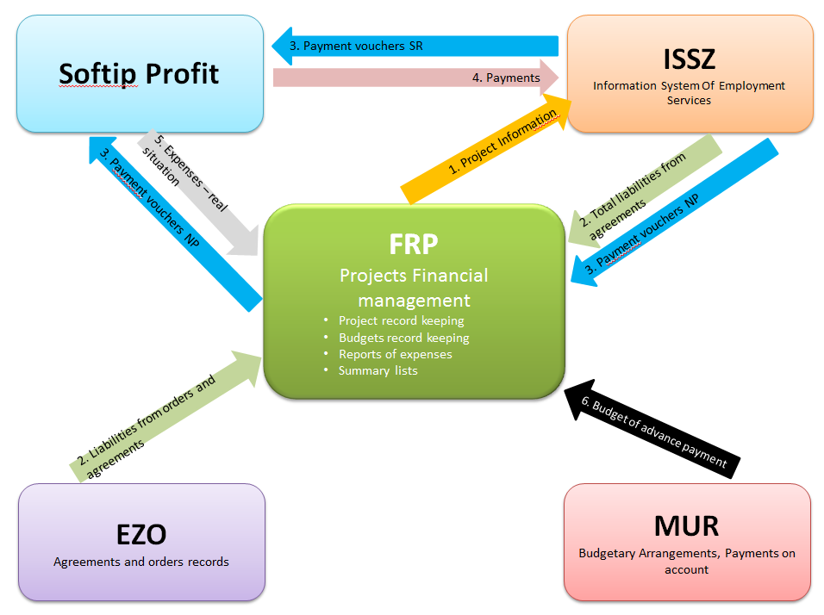
Figure 4 Current implementation of the FMP in Slovakia

Goal:
- Unified Project Registration
- Record keeping of shared sources of funding (national funds, EU funds)
- Centralized financial monitoring and evaluation of projects
- Simplification of fund-raising documents for the creation of lists of expenses
- Improving financial tracking and management of projects on the basis of online information-gathering from the economic system
- Monitoring the amount of liabilities from agreements registered in LMIMS
- Data transfer from LMIMS into the economic system
- Data transfer from the economic system into the LMIMS

FMP keeps track of the following data related to the project:
- information about the project
- the project title
- the project code
- duration of the project (from – to)
- the project commitments (from – to)
- The project budget
  - items
  - subitems (ALMP tools, aid schemes)
  - accountant keys
- Commitments
  - total amount (in process of signing the agreement or addendum)
- Payment vouchers from the state budget
  - amount to be paid
  - method of payment
  - account number of the beneficiary,
  - identification of the recipient - Name / ID / registration number, full address including postcode,
  - budgetary classification, accounting regulation, agreement number, variable symbol
- Payment vouchers
- information from the payment voucher of LMIMS goes into FMPa - in the FMP ESF Department approve the payment and fill:
      - Payer's account number (advance or interim payment)
      - Number of agreement
      - Date of signing agreement,
      - Tax Identification Number
      - Name of institution
      - Request for payment number+ date,
      - Desired amount
      - Amount paid
      - Name and code of the project
      - Instrument name of the office
      - Date
      - Period
      - Method of payment (bank transfer or address)
      - Type of expenditure
      - Beneficiary's account number,
      - Address with zip code
      - Budget classification
      - Aaccounting regulation

- Payments:
- the amount paid
- the date of payment
- the identification of payment
      - number of account statement
      - sequential row number on the statement
- Finacial structure:
- actual expenditures in the accounting system (active policies, invoices)

Case Management System within LMIMS
Processing of each substential agenda of the LMIMS runs through the cases and activities. Cases are managed by the case diagrams. The cases consist of activities (operations). Transitions between activities are managed by state model of documents, vacancies a filling of vacancies.

The general structure of the case in LMIMS:
- Input document - eg. a request
- Participants of the case - the applicant, supported client
- Vacancy – Standard JV, Supported JV, learning activity (vacancy - profile)
- Filling of JV – by employees or Job seekers
- Sources - the amount of the allowance granted, to what place and for what period
- Output documents - eg. agreements, decisions
- Execution of payment - a payment request, proof of payment, recording payments (amount, date)

User Administration
- Record keeping organizational structure PES
  - Record keeping of Offices
  - Record keeping of organizational units (including all workplaces)
  - the assignment of addresses (villages, cities) to organizational units
  - Record keeping of departments
- Registration of users
  - the creation and termination (Termination) accounts (managed by Microsoft AD)
  - Record keeping of signatories
  - Record keeping of facsimiles
  - Record keeping of dividing clients and assigned LO staff to users
- Record keeping of authorization
  - Record keeping of working teams
  - Assigning users to the working teams

Profile Search

Job Vacancies searching system
Job Vaccancies searching system:
- JV Type
- Office (Localities in scope of Labour Office authority)
- Localities
- Education
- Professions - ISCO - requested and prior occupations
- Certificates
- Education
- Driving license
- Language knowledge
- PC knowledge
- Health status
- Disadvantages
- JV suitability
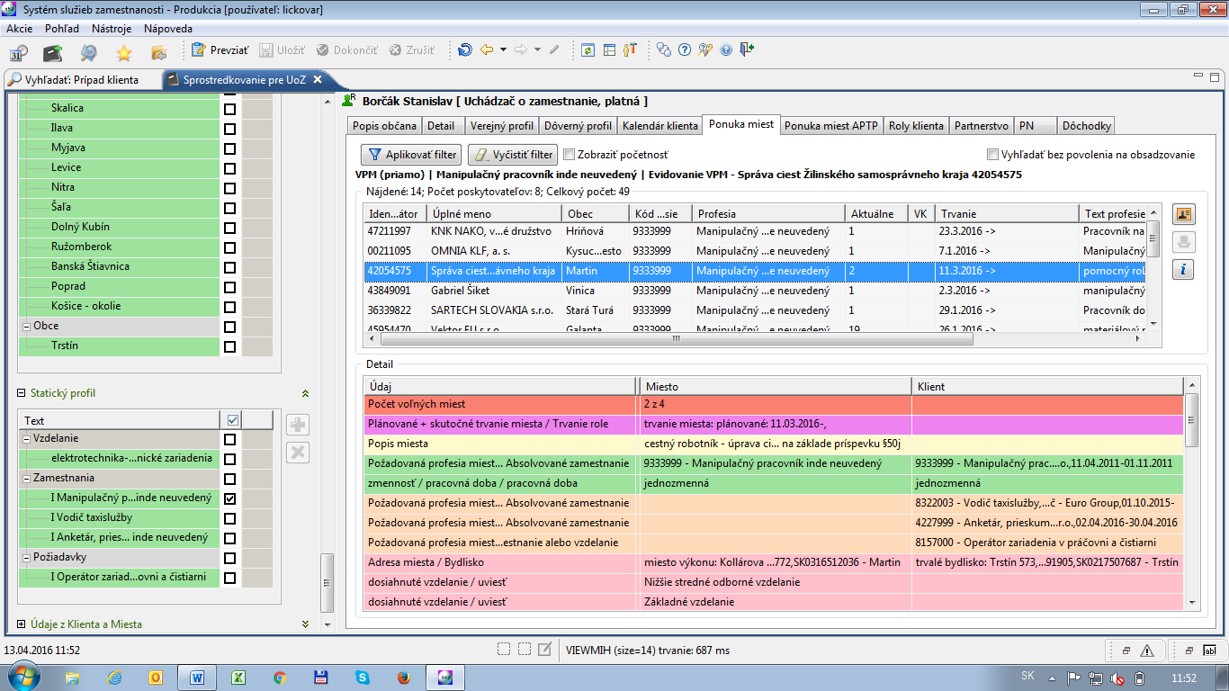
Figure 5 Vacation search within the user’s profile

Jobseekers offer:
- Role
- Address
- Office
- Profession – ISCO classifier
- Field of study
- Certificates
- Education
- Driving license
- Language knowledge
- PC knowledge
- Health status
- Disadvantages

Job seekers searching system
Search functionality allows to find people searching for job suitable for filling vacancies on the following basis:

Search of candidates profiles to match vacancy profiles
- Search of candidates who match vacancy profile and vice-versa.
- Search of profiles relating to employment of foreigners allowing market research before giving working permission.

Search of candidates profiles to match supported activities
- Search of people matching profiles of supported activities and vice versa.

In users’ profiles is able to search for these main datafields:
- Role
- Address
- Office
- Profession – ISCO classifier
- Field of study
- Certificates
- Education
- Driving license
- Language knowledge
- PC knowledge
- Health status
- Disadvantages

Role of calendars in the system

LMIMS User’s calendar
Each user of the LMIMS system can use the calender which offers following features:
- Planned activities
- Scheduled contacts
- Capacity Planning
- Absence from an appointment
- Filter
- Management (transfer to another investigator)
- Work buffer
- Document Tray
- Deadlines (monitoring of deadlines)

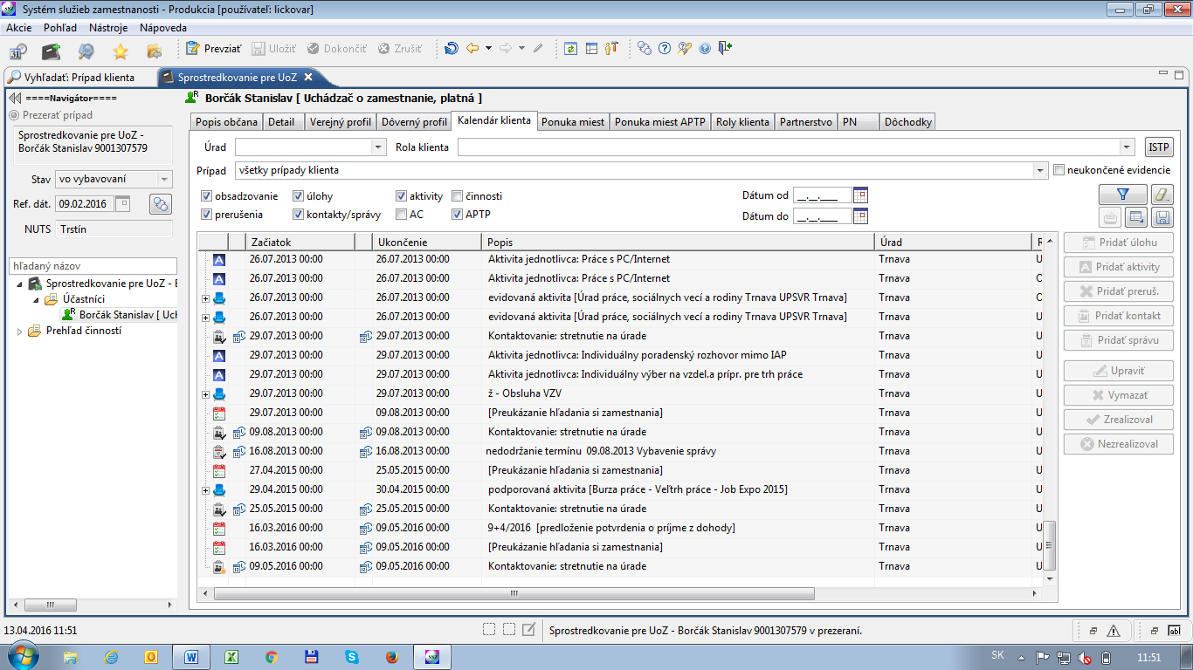
Figure 6 A view of the user's calendar (user from the PES)

Client’s calendar
Client’s calendar is available for each client in ISSZ. Client’s calendar offers following features:
- JV filling
- Tasks
- Activities
- Planning and Evaluation contacts
- Suspension of roles
- Employment Recommendation
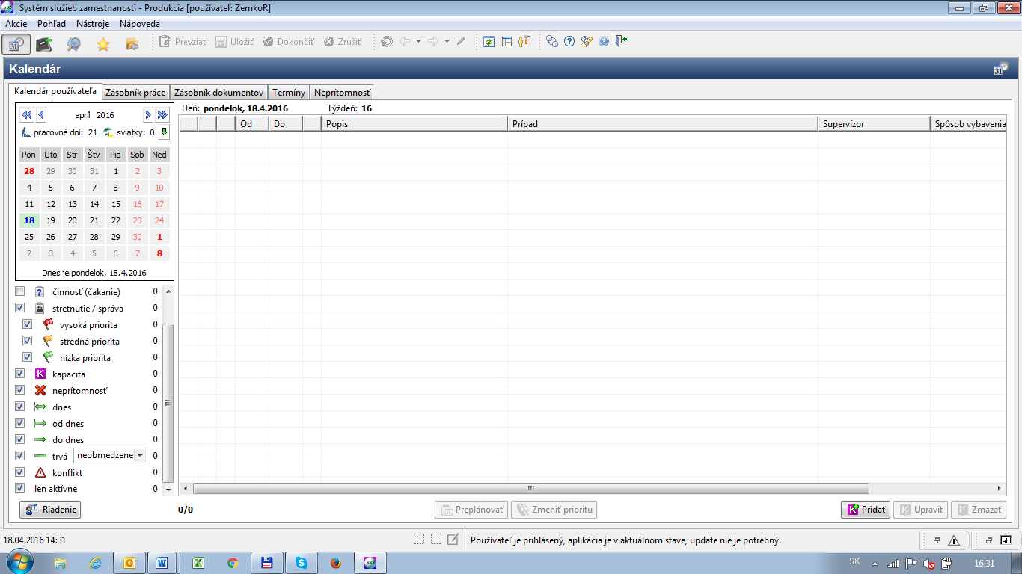

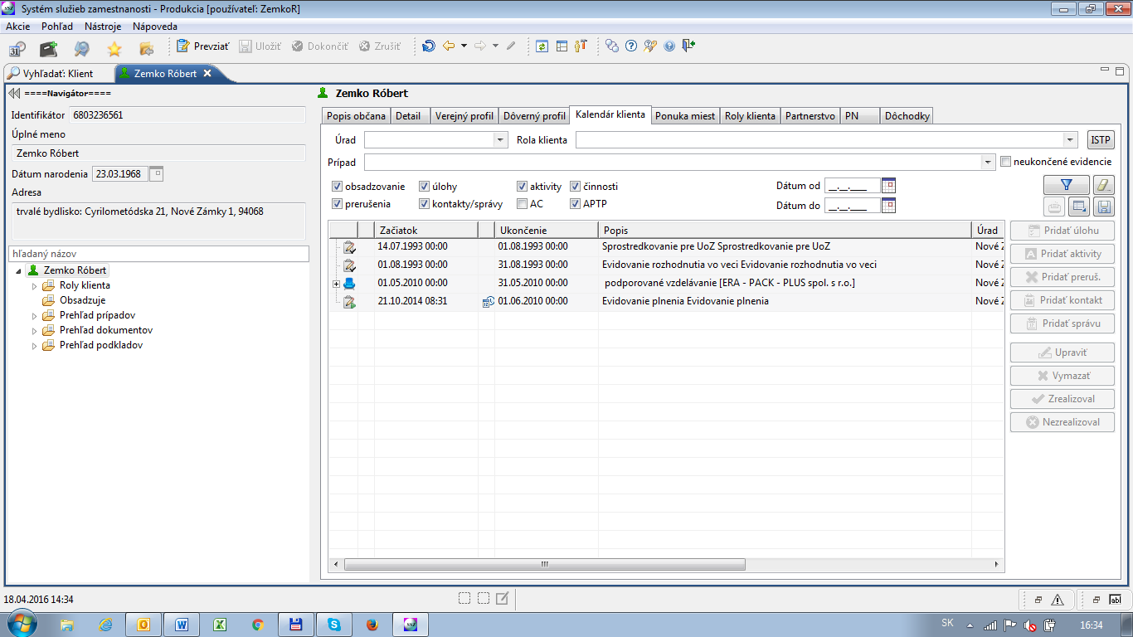
Figure 7 Other views on the calendar

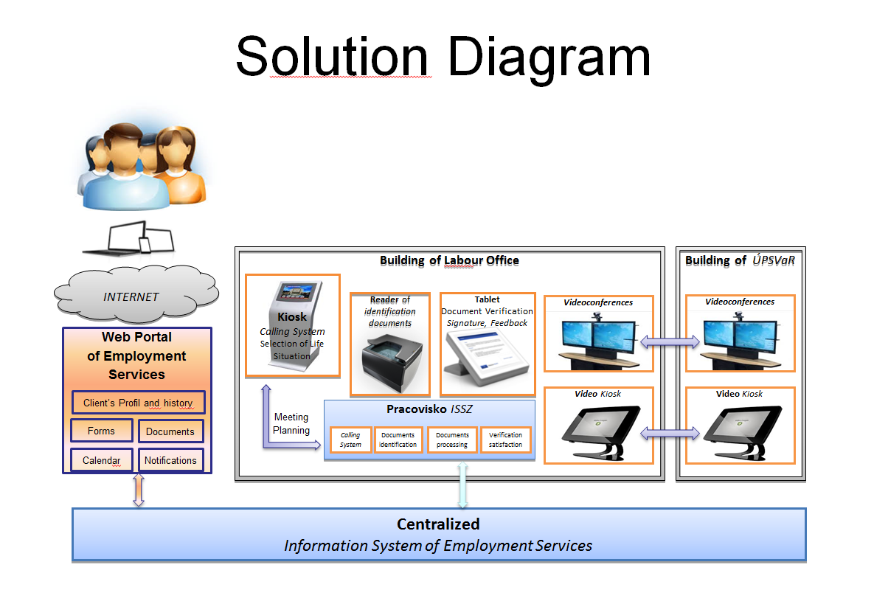
Figure 8 Other components of the LMIMS solution

Other components of the solution
- WebPortal of LMIMS
- Client Calling System
- Documents reader
- Signing tablet
- E-learning

WebPortal of LMIMS
- The cornerstone for the further modernization of employment services is a service that ensures the communication between clients and Labour Office through the WebPortal and the public Internet. The Service includes e-mail messages (or multichanneled messages) and support for sending SMS messages.
- WebPortal provides the clients with ability to enter data, presentations and disclosure of information by extending the functionality of LMIMS.
- WebPortal enables for the clients to arrange meeting in the Labour office
- WebPortal is connected to LMIMS system. In fact, there is no reason for the data replication and/or synchronization if the direct access to the data can be ensured in a secure way.
- The following functions are provided for a client:
  - User profile
  - Forms
  - Calendar
  - Documents
  - the Inbox for messages
  - Notifications

Note: There is client data verification (identification) made after receiving data from the UserForm sended by client (verification is made on the base of data stored in database of LMIMS).

Calling system
Calling system is designed for large-scale service of customers waiting in the queue, which arises by limited capacity for providing of some services.

Calling system provides following functionality:
- Management of the distribution of work
- Assignment of the work according to the distributing of workagenda OSO
- Cooperation with LMIMS to "prefer" active clients
  - (Client using functionality for scheduling meeting on the portal of LMIMS)
- Cooperation with LMIMS to "prefer" clients in repeating contacts (meetings) on Workplace of OSO

Following cases are served from the perspective of planning work by calling system intercom systems as the:
- arrival of the client with valid reservation to the workplace OSO
- arrival of the client without valid reservation to the workplace OSO

The main components that provide functionality of the calling system follows:
- Order terminal (KIOSK)
- Main - indoor displays
- Calling terminals

Documents reader
With the goal of enhancement, the quality and speed of the clients handling, the LO workplaces are equipped with IDcard readers, which significantly contribute to faster customer identification on the basis of submitted documents and avoiding errors caused by manual input of client data into information systems.

Note: after loading the data from the ID Card the process of verification (identification) client in database ISSZ is done.

Tablet for signing document
With the goal of implementation of paperless processes at LO workplaces signature devices (tablets) are implemented. They reduce the administrative burden in process of dealing with clients and actually existing scanning signatures from paper originals.

eLearning
- The important aspect for improving the efficiency of work is to ensure quality and effectiveness of employees training.
  - An important challenge for Employment Services is to provide continuous training for 1,850 employees.
- ELearning system is suitable tool for such a volume of continuous training respondents.
- Working with eLearning system allows respondents to realize individual learning process (self study), as well as learning in groups via virtual classes, with participating of the teacher on education process.
- As part of the Twinning project a Moodle-based platform is proposed as a repository for both materials created during the project but mainly as a tool for self-paced, self-assessed trainings for the offices which undergo reform later on. This platform can be also reused as a supporting system for LMIMS.

Integration with external systems
Following is the comprehensive list of institutions, with which the LMIMSs in Slovakia and Czech Republic have their interfaces. This list contains the name of the institution (generalized, so that it can be projected to Georgian environment) and a brief description of the data exchange reasons.

National Labour Inspectorate
- Cooperation in control of prohibition of illegal work and illegal employment
Health Care Surveillance Authority
- Exchange of data about subsidies for the people providing care or personal assistance
- Exchange of data about people with severe disabilities and/or requiring assistance
Radio and Television
- Exchange of data about exemption from monthly fee levied on most individuals registered with electricity retailers
Health insurance companies
- Exchange of data about current body covering the health insurance
- Exchange of data about fulfilling the conditions for financial support during unemployment
National Post
- Subsidies and compensations payments (structured by the type of fee)
Statistical Office
- Data provisioning based on the current national legislation
Trade Register
- Data exchange (load) for the agenda of social affairs and employment services
Ministry of Education and its Institutes
- Data/statistics provisioning for the analysis of the high school and university graduates placement
Department of Motor Vehicles (Vehicles Register)
- Data exchange about car ownership for the subsidies assessment and for the new car procurement contribution
Financial Administration
- Data provisioning about personal entities receiving subsidies (taxable)
- Data exchange about debts
- Data exchange about tax declarations

Social Security Company
- ALMPs assessment
- Tax and contributions deduction for the unemplyed
- inspection of the employment of the foreign citizens
- assessment of the availability and length of the unemployment benefits
- information about fines imposed
- list of employers for the assessment of their obligation to employ handicapped citizens
ITMS (Information and Technical Monitoring System – EU Funds)
- Planning and controlling the resources from EU Funds
Other data exchanges within LMIMS:
- Tax declarations
- Back taxes
- Register of businesses (kept by Statistical office)
- Register of tax payers
- Register of convictions
- Health insurance back payments

Reporting
The proposed reports, their format and the data contained is discussed and described in the documents created within Activity 3.4 of this Twinning project.

Non-functional requirements

Environments
Typically, during the implementation of LMIMS, following environments are created:
- Production environment, where LMIMS backoffice as well as clients’ self service portal run.
- E-learning environment for training of the backoffice users for changes
- Test environment – where new features are deployed and tested prior to their deployment to production environment
- Proof-of-concept environment – where changes in the business rules are tested, mock-up reports of to-be state are created etc.
- Development environment – if the development is not outsourced to a third party implementator
If the DWH is considered as a separate project, then another set of production and test environments must be setup.

Communication model
The new LMIMS will be implemented on the following communication model.
- The LMIMS system will be hosted within the MoLHSA data centre in Tbilisi
- SSA Staff in Tbilisi can access the data centre via the WAN
- SSA Branch Offices can access the data centre via the VPN mechanisms (they currently use?)
- The system interfaces will be secured and available through WAN/VPN only
- Certain forms will be published on the my.gov.ge portal, especially the ones, that do not require extensive interaction but are rather of submit-and-forget nature.

Desktop vs./and Web architecture
Before the implementation a discussion should be held about the form of applications developed. While WorkNet is currently web-only application (with few exceptions for reporting, where out-of-box SW such as MS SQL Server Management Studio or Excel is in use), it turns out, that for the branch offices a desktop version should also be considered as an option. The nature of work of the staff at the central and local offices requires fast manipulation and features, that are harder to implement on web (e.g. advanced calendaring).

Knowledge Management, Collaboration Platform and Project Management
The use of a central project and collaboration repository (SharePoint or comparable product) with version control to manage all assets of the project is strongly recommended.

All documents issued as interim deliverables or final deliverables must be version controlled. Because such project requires rather extensive modelling a UML tool should be in place in order to encompass the full solution.

For the management of trainings, a supporting solution should be established where trainees can empower their knowledge from the live trainings. One of the natural candidates for such a solution is Moodle system, which is free and allows for creation of courses, learning modules and activities (e.g. learning material, video, self-paced test, forum, etc.). Moodle runs on several platforms (OS and Database combinations) and as such will be introduced in the Twinning to the SSA users as an repository for the training materials with a self-testing functionality.

Project Documentation
The application software user screens and documentation shall be in Georgian language. The documentation shall be prepared using ISO 9001:2000/9000:2015 (or compliant) based structured system and design methodology. It will include at least:
- A general system overview
- Function by function process description
- Function by function data flow diagrams
- A description of all user interfaces
- A general description of data structures
- Data dictionary
- Modelling Language definitions
- A description of standard reports
- User, administrator and support manuals

Security, logging and audit
The potential for unauthorised external or internal access must be minimised. Data must be protected by a combination of system and clerical procedures incorporating the following security features:
- The system should monitor all access by users and provide a comprehensive audit trail (Test checks, Exceptional [suspicious] activity reports, Supervisor/ management reports, Transaction recording).
- The system must be fully protected by strong authentication (as described in Chapter 9.2), including network and systems protection where appropriate. Security must be user oriented as well as data or function execution oriented. In any case the password facility must be multi-level (at least two-level), embedded, and be capable of assigning simple or combined privileges based on:
  - Display Screens, (permission: view)
  - Menus, (permissions: view, execute)
  - Display Screen Fields, (permissions: view, change)
  - Reports (permissions: create, view, print)
  - Execute procedures, functions etc.
  - Read data
  - Add data
  - Delete data
  - Change data

Hierarchical levels of access are essential for this system and therefore IAM and OrgChart modules should be designed generally enough to accommodate Case/Process/UI permissions and hierarchies.

The system requires programme protection to prevent:
- Accidental/Occasional programme damage by non-qualified users;
- Intentional programme or data damage;
- Unauthorised copying and distribution of security sensitive information.

Scalability, availability, extensibility
The design of the servers (physical/virtual/balancing elements) must allow good scalability in terms of scaling out (e.g. load balancing of communication/application server) or scaling up (especially DB server), even in case of lower than needed preliminary budget. The growth in the traffic can be predicted on the side of the internal users (MoLHSA), but is hard to predict on the side of the users - jobseekers (it largely depends on the system acceptance as well as obligations resulting from legislation).

It is obvious, that the availability of solution depends on the chosen hardware, standard software, hardware and software clustering and infrastructure support and on availability of external systems. The system should use the latest technologies (instead of relying on proprietary mechanisms) to achieve the highest possible availability. The expected availability is not set neither in this document, nor in the Terms of Reference, however the standard lies somewhere between 99% - 99,9% (especially for the web portal, allowing service window between app. 8-80 hours a year).

Security procedures: Backup and recovery
The system must incorporate comprehensive procedures for regular (daily, weekly, monthly) and ad-hoc back-up and restoration of all system files and data to guarantee recovery in the event of hardware failure.

The back-up and security features must be capable of being used by technical and trained personnel. The ‘back-up’ and restore procedures must be automated and supported with user manuals and training.

Trainings
The requirements for the trainings are described in the Chapter 6.8 as assumptions for the system functioning.

Principles and architecture of LMIMS
Based on the chapter 7 and 8, following chapters deal with the potential architecture of the LMIMS. It may vary depending on the specific implementation and implementator, however, certain principles are common for such a system, regardless of the implementation details.

General architecture principles
Generally, the LMIMS is centralized system with a central database/databases, which can be replicated for security reasons e.g. to the web portal solution. This solution is particularly advantageous in terms of the following basic requirements DB that the centralized system better fulfilled:
- Safety data against unauthorized access or loss,
- Ensure the validity of production rules
- Correct sizing of the DB on hardware and software level to ensure the expected (fast) response time
- High availability of the entire information system backup, not only in hardware but also multiple geographic locations,

Database specifications in more detailed description:
- For the main part of the system using OLTP (Online Transaction Processing) database type, which is designed to handle large amounts of short transactions and a large number of parallel approaches,
- Incorporating controls of production rules directly into the database, thereby avoiding the possibility of violations at the inputs from outside the application (upgrades, migrations, servicing), ie. DB logical and semantic consistency protect herself.
- Incorporation of mechanisms for automated storage of history for selected data, what allows to:
- Audit of the entire system;
- Prepare production rules that responds well also for data stored in the past;
- Searching arising errors and their causes and to develop procedures for recovering from them.
- Incorporate mechanisms for automatic logging of changes in the structure of DB.
- DB deployments together with a console for enabling of monitoring and the detection momental peaks of loads and searching for specific DB operations that caused such a tip.
- For application components addressing the issue of statistics and reports seems appropriate architecture DB OLAP (On-line Analytical Processing) with usage of the mechanisms of Business Intelligence,

Setup of system capacity:
- Application must be dimensioned for the bulk of concurrency all users working in all agendas (number to be estimated in the side-by-side prepared Institutional Reform Plan #2)
- Access into the specific segments of IS for public users
- In addition to the production environment is an important requirement to build these environments as well, with a performance that can be sized to significantly lower the load:
- Test – used for testing of new versions of the IS before deploying to do production,
- Training - used to train new users,
- Experimental - suitable for the user to verify the procedures performed especially after the deployment of new versions or users with little or no experience,
- Necessity for solving competitive access by multiple users to identical data, minimizing the use of locking mechanisms for securing the highest throughput system interactivity,
- Ensuring the protection of Privacy according to the standards of the EU:
- physical location within the EU,
- Restrict access to personal information to third parties,
- Restriction of access rights according to the agendas and singular functionality in actual agenda,
- Restrict user access to particular objects under local or other jurisdiction,
- Monitoring data changes and all access of the users,
- Logging the history of made changes,
- Communication on secured dedicated lines for data transfer in the main application encryption of transmitted data,
- User Access (of agenda workers) to the main part of the protected application logon certificate
- The main application area for the work of agenda workers is separated from the system intended for the public and from third-party systems:
- Communication of the major application area with other parts and systems only via defined interfaces (mostly Web services)
- Possibility of mobile workplaces for the selected agenda workers (inspectors, etc.).

Authentication
- For logging into the system the two-factor authentication based on cryptographic smart cards containing authentication, X.509 certificates and private key pair must be used. Authentication certificates must be issued by a certification authority dedicated for this purpose (or national CA). Without smart cards it is not possible to log into the system. In the case of lost or malfunctioning card is for a limited time universal card issued. This card is by administrator of the system temporarily allocated to the user.
- During the authentication system checks the validity of the certificate, based on the inspection of certificate revocation list (CRL). The CRL must be online service with high availability, provided at least by two sources through two different mechanisms, since this is a critical service, without which it is impossible to work with the system.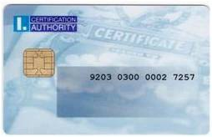

Access Rights

- Records of user accounts
- Authentication through a secure authentication mechanism in the form of a certificate placed on a personalized smart card,
- Option to use a universal replacement chip card, which is for a limited time assigns employees eg. at the time of invalidity of the certificate, forgetfulness or malfunction of personalized smart cards,
- Mechanisms for universal registration of replacement cards assigned to individual users and tracking history
- support using of signature certificates placed on personalized smart card for adding a recognized electronic signature to electronic documents,
- issuance and management of smartcards, subsequent certificates, revocation of compromised certificates
- definition of elementary permissions for individual events within the system with different levels (editing, viewing, etc.)
- associations of elementary authorization with an appropriate level to roles based on user activities
- mechanisms for resolving access to individual parts of the system on the basis of registered roles and permissions partial control over the entire system,
- configure user settings:
- organizational affiliation (contact point, workplace)
- functional position of worker
- superior authorized official person who approves appropriate actions
- configuration scanned the stamps and signatures generated in press reports,
- a list of roles arising from the activities performed,
- evidence associated with personal smart cards, respectively. temporarily assigned to the universal replacement chip cards,
- evidence of authentication / signature certificates assigned to the user,
- default settings for each application component.

Further reference: http://ecdc.europa.eu/en/aboutus/calls/Procurement%20Related%20Documents/PROC_2014_023_Tender%20Specifications_corrected.pdf

Multichanneling
In the context of increased demands coupled with greater budgetary stringency, finding the most effective and efficient ways to deliver services to job seekers is among the core. One way in which ESS should deliver this is to target service delivery more clearly to individuals in greatest need of assistance and providing those capable of helping themselves with effective tools to do so. Multi-channel management (MCM) is one strategy available to provide for better targeting. It also responds to citizen‟s desire for more flexible and accessible services, for example by delivering access to information around the clock through online services. The development of MCM depends on the level of internet connectivity, digital access and digital skills among the user population The ability to implement a successful ESS MCM strategy (and the precise nature of the channels and tools used) is predicated on three factors:
- The level and quality of internet service coverage;
- The degree of internet usage among different individuals (and the key client groups for ESS services in particular);
- The extent to which core client groups possess the required digital skills to interact with new media.

From the technical point of view, the most important request for possibility to setup new multichannel services is given in item 1) The level and quality of internet service coverage.

The data obtained from the official Georgian body: GEORGIAN NATIONAL COMMUNICATION COMMISSION shows, that there is quite high penetration of internet in Georgia and specifically good situation is in Tbilisi and its surroundings -penetration of Internet is higher than 80 percent (see picture: Penetration of internet in Georgia – Source: GEORGIAN NATIONAL COMMUNICATION COMMISSION)

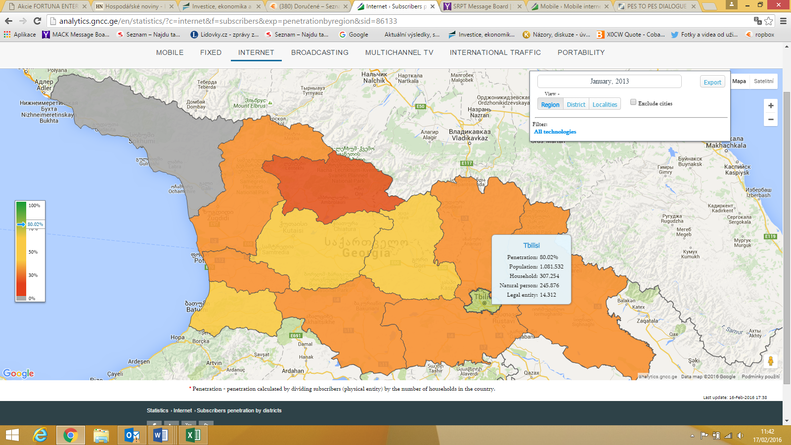
Figure 9 Penetration of internet in Georgia – Source: GEORGIAN NATIONAL COMMUNICATION COMMISSION

Following 3 pictures gives the overview of development situation on the field of using internet by Georgian legal entities and persons in 2013 – 2016 period. There is clear steadily growing trajectory of using internet both Legal Entitas and Natural Persons what illustrate, that there is quite significant target group which can use multichanelling Georgia if this solution will be adopted on ESS.

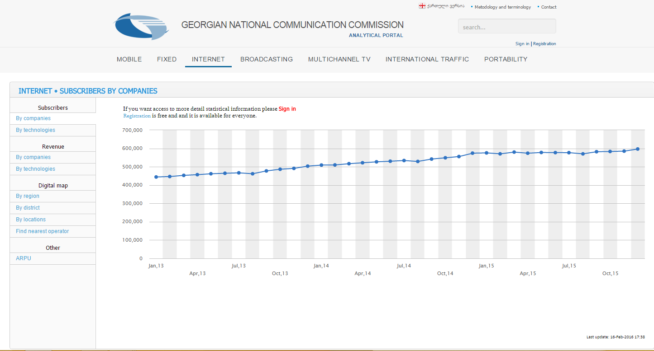
Figure 10 Number of Internet subscribers – Source: GEORGIAN NATIONAL COMMUNICATION COMMISSION

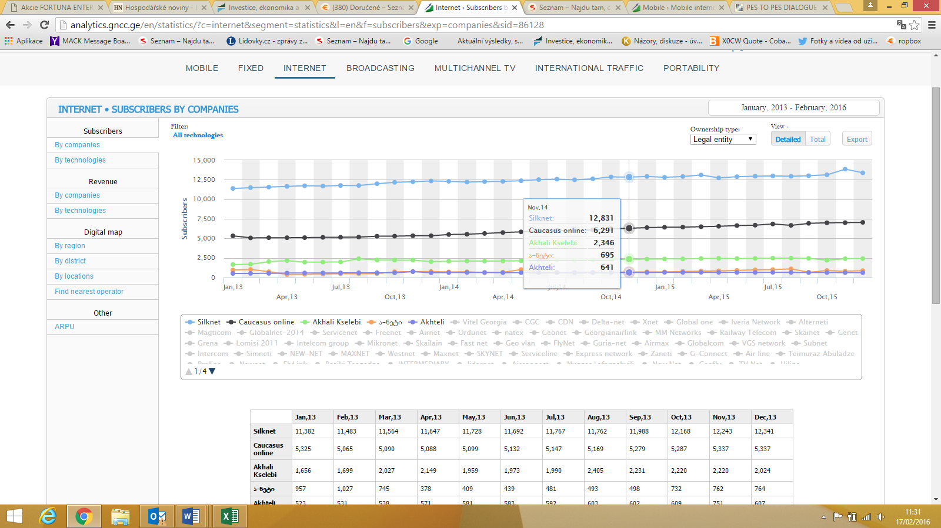
Figure 11 Number of Internet subscribers: Legal entities – Source: GEORGIAN NATIONAL COMMUNICATION COMMISSION
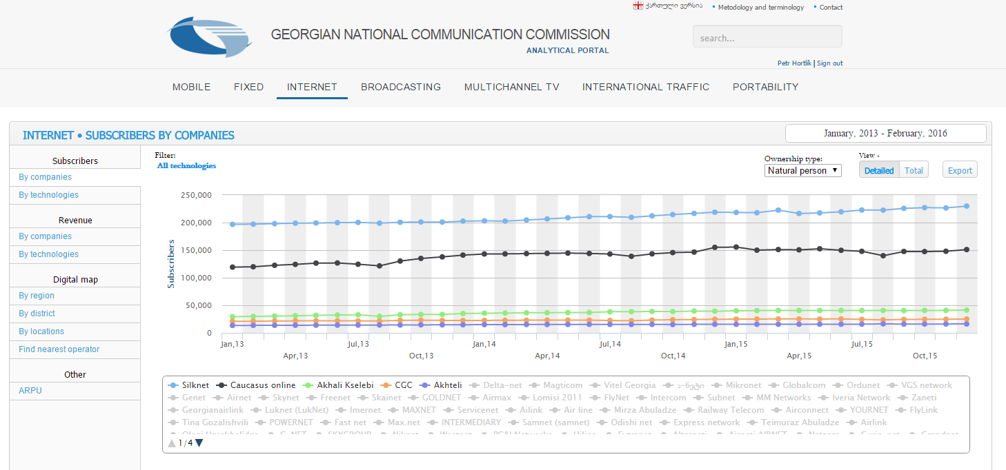
Figure 12 Number of Internet subscribers: Natural persons – Source: GEORGIAN NATIONAL COMMUNICATION COMMISSION
Specifically, the situation appears to be good in the field of Mobile Internet. The number of subscribers grows steadily and mobile traffic is growing especially in the last period substantially (see picture: Mobile Internet Traffic).

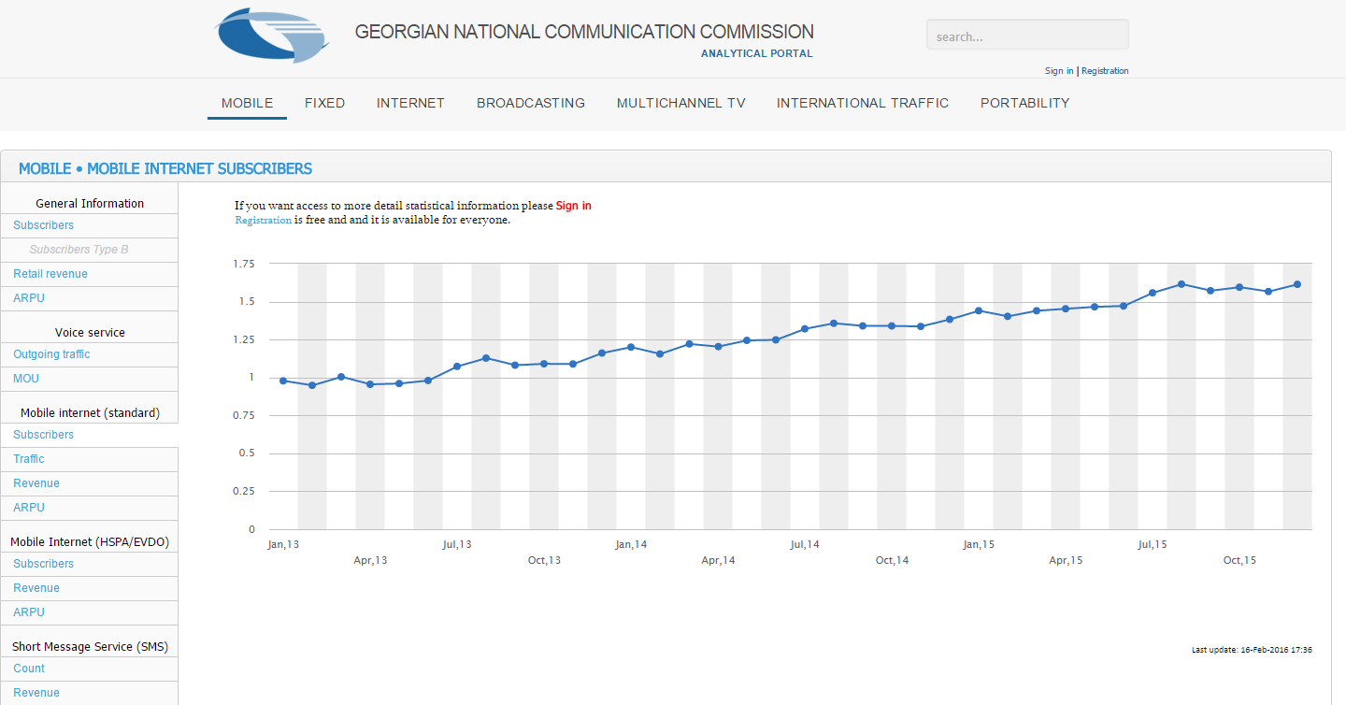
Figure 13 MOBILE INTERNET SUBSCRIBERS – Source: GEORGIAN NATIONAL COMMUNICATION COMMISSION

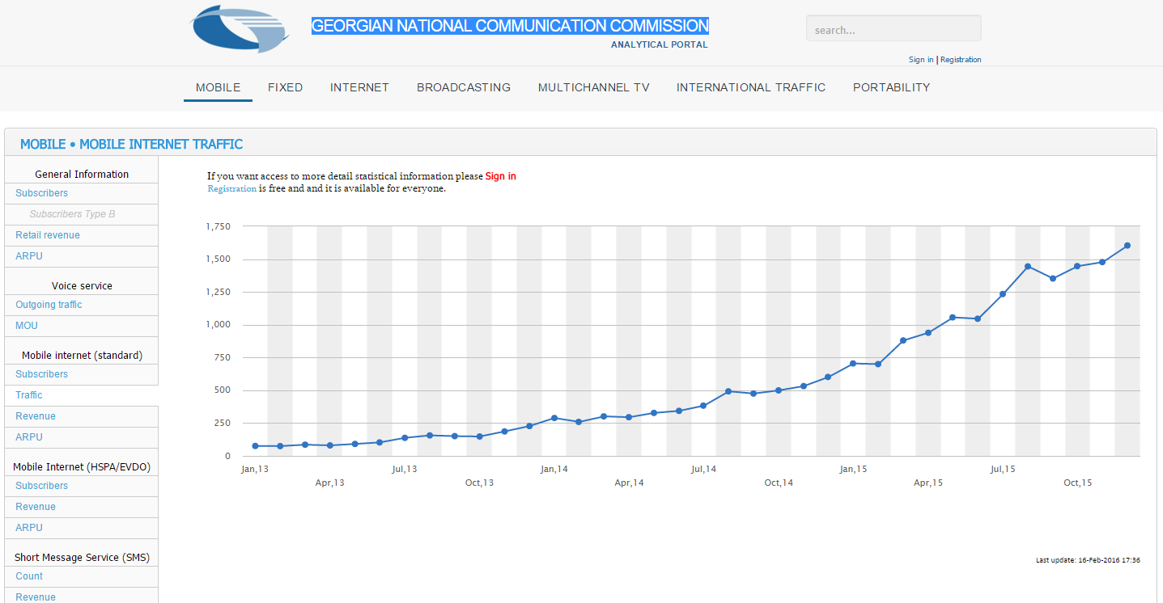
Figure 14 Mobile Internet Traffic – Source: GEORGIAN NATIONAL COMMUNICATION COMMISSION
Above mentioned data concerning internet penetration and mobile internet penetration shows, that from the technical point of view, there are no significant obstacles for implementing multichannel solution on ESS. At this moment exists significant target group which can use some online service and the size of potential target group is growing speedly. On the basics of this data is possibly to pronounce that multichanellin solution can bring for ESS and its clients substantial added value.

We expect, that in Georgia as well as in other European countries, become more and more dominated by digital forms of delivery, replacing more traditional face to face channels. Citizens are increasingly conducting their banking and other commercial transactions online as this often provides them with the added convenience of access over a wider range of services at times that suit their lifestyle.

ESS and other governmental organisations in Georgia have also been seeking to utilise the advantages of these new channels, partly learning from similar applications in the „private‟ sphere.

The next step on Employment field, we believe, should be implementing of multichannel system which should at the same time mindful of the different requirements underpinning public service delivery, particularly with regard to equality of access, equity and social inclusion.
The time when all interactions between PES and jobseekers would have been conducted either face to face, by letter and to a more limited extent over the telephone is over.
As a result of the increasing proliferation of the internet and mobile communications Services in Georgia, online, email/SMS based channels of interaction has to be opened up and being increasingly utilised.

Multichanelling Strategy
There were 4 basic strategies for multichanelling in PES identified by Pieterson and Van Dijk, 2006:
- Parallel positioning: Services are offered via all channels with citizens free to decide which channel to choose. Such a strategy may be necessary at the outset but in the long term does not appear to be efficient as such an approach can make it more difficult to target scarce resources to those most in need of assistance.
- Replacement positioning: Channels replace one another based on the assumption that one channel is more effective and efficient than another for a particular task/client group. It is assumed that customers want to (and are able to) use the best channel and one channel can therefore replace another (immediately or over time).
- Supplemental positioning: Each channel has its own characteristics that make it suitable for certain services/client groups. It is therefore assumed that governments should offer services via the best suited channels.
- Integrated positioning: In this model all channels are integrated in the entire service delivery process. This means that all services are offered via all channels but that the strengths and weaknesses of channels are considered in their design. Users are steered to the best channel and channels integrate seamlessly.

In the reality of the SSA, the actual application of MCM is more complex and nuanced. We recommend to go in the process of implementing multichannel approach in SSA in Georgia by the “step by step” method. In the beginning, we see as the most efficient to use parallel positioning, making newly developed channels available in tandem with existing means of communication.

After the creating all basic multichannel channels we suggest to integrate all this channels with the goal of Integrated positioning of MCM.

Characteristics of singular types of channels and their expected using in Georgia

Channel characteristics show different strengths and weaknesses. In order to maximize the effectiveness and efficiency of different channels, a key consideration is to match the right channel to the right task.

It is clear, that some channels are clearly better suited to certain tasks and situation in Georgia than others, depending on the complexity and ambiguity of the information to be communicated and tasks to be carried out.

The decision which channels and in which form are fully in hands of Georgian representatives. Experts of Twinning Project “Capacity Building of the Employment Support Services (ESS) in Georgia” after the fruitful and detailed discussions with Georgian partners suggests following channels for the next 5 years’ period:

Face-to-face services – although face- to face service remain very important channel of SSA interaction with client, in this document will not be specify in detail way. The reason for this decision is the purpose of this document which is oriented on IT and electronic services. From IT point of view is important to implement efficient backend and frontend tool for SSA staff, which allows cooperation with other channels. Descriptions of requested demands and technical specification for this tool are given in other parts of this document.

Telephone channels - Call center solution - this form of communication is often used for information giving and to supplement online and face to face channels. We believe, that this channel can be useful primarily for clients from remote parts of Georgia. From technical point of view, there is using of Ministry of Labour, Health and Social Affairs Call center anticipated, what correspond with actual situation.
The range of functions provided by Call center can reach from the basic (through automated messages) to personalized follow up of SSA clients.
The minimal set of functions which should be ensured on Call Centre follows:
- Answering basic set of question from field of Employment. The set of questions which will be answered by Call center staff and correct answers for these questions will be prepared by specialized departments of SSA
- Database of experts on SSA will be implemented as the integral part of technical solution. Call center staff will resend the questions which surpass standard questions of clients (defined in prior item) to these experts
- Connection between Worknet platform and Call center technical system will be setup. This connection gives possibility to call center staff use database of job vacancies from Worknet platform and information about selected vacancies deliver to client by telephone or by e-mail. The same situation will be in the field of CV and potentially with other database information stored in Worknet platform.
- Possibility for putting information directly into Worknet platform for be Call center staff will be setup (the set of information which can Call center staff put into Worknet platform will be defined and treated on the Worknet access right level).
- The Interactive Voice Response (IVR) system will be adopted with following minimal set of functions:
  - EDRs & CDRs (Event & Call Detail Records)
  - Highly scalable IVR
  - Based on vXML & cc-XML
  - All requested standard interfaces/open standards
  - Module for pronouncing dates, time, CLI etc
  - Multi-language support
  - Web-GUIs for maintenance / configuration
  - Supports multiple protocols at the same time
  - Gateway functionality (e.g. ISDN in - SIP out)
  - Transfers & full call recording

- Statistical system – system will allow to identify:
  - the most requested answers
  - optimal working hours of call center
  - the quality of service (speed of more complicated answer resended to expert)
  - load of individual Call center operators
  - …..

Online services for routine and selected complex functions – preparation such type of solution is the big challenge for Georgian public employment services. Online channels become more sophisticated and their connection with other chanells has to be prepared in rigorous way otherwise added value is lost.

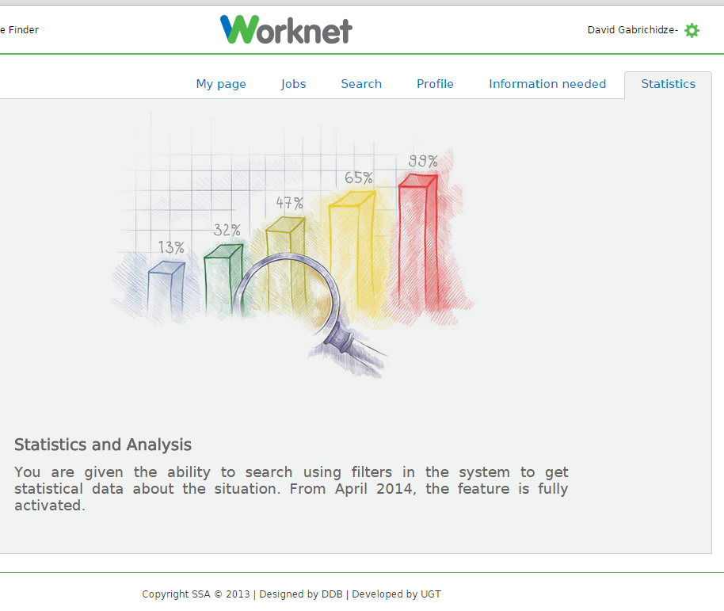
Figure 15 Illustration – Picture of Worknet platform screen
The following functions implemented via Worknet platform are anticipated:
- Electronic tutorial for clients (Employers as well as Jobseekers)
- Electronic Labour Market with using of of automatic matching tools
- Possibility for automatical sending of information concerning Job Vacancies on the base of
  - Selections condition defined by user (new JV at last xxx days, JV with defined ISCO code, JV in selected region) with possibility to combine various selection conditions.
  - Automatic selection according to personal data of client (previous profession, …)
  - Special request of Concrete Employer
- Basic HR system allowing Employers to communicate directly with clients. This system will give the chance to employer:
  - Create and archive sets of clients from Worknet database of Jobseekers
  - Send SMS or e-mail to client
  - Archive the electronic communication with clients
  - Watch the statistics of interest clients about its JV (the number of displaying single JV, interest of clients in various time periods…)
- Online profiling of clients
- Electronic advisory and councelling tools

The part of online solution should be also solution for possibility to communicate via social networks. This solution is not anticipated on Worknet platform.

However, with the increasing use of online-services this channel might lose weight, we expect its high usage by clients (both Employers and Jobseekers) if the quality of service wil be on very good level.

Main modules of LMIMS System

Core Employment IS
The Core Employment IS is at the heart of the LMIMS solution. It processes the main agendas of the ESS, while relying on other systems, which are described below in this chapter.

Figure 16 Simplified scheme of particular agendas Employment IS in countries Slovakia, Czech Republic, Hungary

Document Management System
Document record management system is a comprehensive solution of administration and management of analog, digital and hybrid documents. Based on integration of DMS and RMS applications (integration with particular agenda systems and external sources related to transfer documents) represents important part of IS Employment which represents:
- Clear evidence all documents and its status in organisation - trusted key system for managing documents throughout the lifecycle
- Data source for analytical instruments, controlling and active management
- The system complying with all relevant EU legislation including MoReq standard
The high priority in process of implementation DMS has to be automatic integration with singular processes in agenda system (automatic generation of reference number and bar code and its printing on all relevant documents)

Economic system (ECIS)
Economic Information System (ECIS) is implemented as complex system including all necessary economic functionalities for the management of the organization.

The most important areas follow:
- Accounting
- Reporting of accounting for the purposes of national accounts,
- A report summarizing accounting,
- Budget
- Budget reporting
- Commitments book of incoming invoices,
- Receivables book sent invoices,
- Receivables - Central evidence claims
- Cash management
- Automated contact with the banks,
- Management of payment orders,
- Assets (proof of real movable property)
- Warehouse management,
- Material and technical supply,
- Orders
- Central register of contracts
- Procurement system,
- Management of state contributions subsidies
- Management for maintenance of applications and users,
- Workflow,
- Approving of documents (within workflow systems)
- The circulation of documents within processes ECIS (within workflow systems)
- Management of Organizational Structure of SSA

Digitalisation and archive of documents
System provides solution for the transfer of documents received in analog (paper) form to digital records according to international standards or Georgian law (if adopted):
- Register of all documents - each documents sheet generated or received obtain the barcode label system
- Registered for each sheet of input document the record storage location. For output documents offer that support, but do not demand.
- Support for general storage location (e.g. Building) or physical storage (plates, boxes, etc.).
- Each physical storage is identifying and registering by the barcode
- Comprehensive solution for the whole problem of archiving - from transportation of documents from various departments on digitization through the creation of a digital image using a scanner and followed up after the removal of the original documents to the Central Registry
- Support for saving output documents (press reports)
- Long-term storage (> 45 years)
- Monitoring the current location of every registered leaf
- Distribution of processed documents to an external archive
- Option to request an original hard copy from an external archive (eg. as evidence in a lawsuit)
- Support for document shredding (physical and electronic)
- Specialized digitization workplace focused on optimized conversion from paper to electronic format, minimizing the need for operator involvement
- Labelling digitized document by electronic signature of the person who carried out conformity of electronic form paper, digitized documents are supply by time stamps (can collectively)
- Batch ensurement of documents by stronger time stamp and signature for the case of breaking hash functions
- Viewing of electronic form documents
- Support for Web services to communicate with literary, collection boxes, recording and realization of loans, confirming handover protocols and so on.
- Material orders (storage boxes, labels with barcodes, tapes etc.).
- Support for the registration and transfer of archival packages to the Registry (i.e. collectively described groups sheets / documents without evidence of the singular sheets)

Chip Card management
Chip cards management system is designated for safe issuing and using chipcards by all new users and existing users in compensation for lost or damaged cards. The system must further allow issuing called „Universal cards “(that are not issued by a particular user). Issuing 300-500 cards per year is expected. Smart cards are primarily used for:
- logging into Active Directory system
- logging into agenda applications
- advanced electronic signature of agenda applications
- data encryption
- e-mails.
Card management system must include the card center ort he other Governmental ChipCard center must be used. This Card Centre must provide at least the following activities:
- Safe storage and use of cryptographic keys in HSM
- Creating a record of personalization profiles
- Personalization card printing
- Personalization of contact chip card with systems GlobalPlatform and Java Card
- Acceptance of applications for issuance of smart cards
- Issuing certificates for personalization
- Upload safety objects
- Print PIN envelopes
- Support for the distribution of cards and PIN envelopes
- Creating accounting reports
- Lifecycle Management of issued cards
- Intake of applications for change of status cards

Registration authorities receive and examine applications for chip cards and certificates and authenticated requests forwarded to a card center.

PKI System
Public Key Infrastructure PKI will provide services related to the issuance and management of certificates for users, roles, smart cards and servers.

Certification Authority
PKI system must allow simultaneous operation of at least 10 CAs. All authorities must have the keys stored in a secure HSM. The system PKI authority will include timestamps solution.
Certification services should be organized in a two-level hierarchical structure, each authority will issue certificates in compliance with the established certification policy and the purpose of the certificate.
CAs must have a central management system for administration, operation and monitoring activities.

Registration Authority
For receiving applications for certificates will serve a network of registration authorities. Registration authorities must allow at least:
- Centralized configuration of services
- Acceptance of applications for different types of certificates

PKI Portal
To work with certificates will be created portal PKI system that allows authorized users to a minimum:
- Publish and distribute CA certificates
- Search for and download certificates issued
- Publish and download CRLs
- Create certificate requests
- Issue a subsequent certificate on the basis of existing, previously issued certificates under certain conditions
- Issuance of a receipt for the filing of applications for qualified certificates issued by accredited providers of certification services
- Revoke certificates upon request

Management Information System
Setup of Management Information system with BI logic containing following features:
- Support for periodic transmission of updated system data into the data warehouse - MIS, this transfer must be optimized in terms of the size of the transmitted data set.
- Cooperation with the analysis system and the ability to perform online reporting of all data.

Statistical Reports
The system of statistical reports will be setup. The system can be implemented as the standalone system or can be the component of Management Information System.
The system allows:
- Creation of statistical reports for a facultative period (day, week, month, …), including the all main fields of activity SSA (number of jobseekers, number and amount of benefits paid….)
- Preparation of ad-hoc queries
- Export of datasets

WebPortal
Besides the web user interface, the system should also contain web portal with CMS functionality. This will allow for publishing of the static texts concerning the functioning of the system as well as general articles about employment, job seeking, trainings, carreer guidance etc.
The Web Portal should have following features, allowing its operation by non-technical content creators:

- Technological system of WebPortal must allow to create and manage web about the extent of 3000 or more static pages and linked documents.
- The Web Portal must seamlessly integrate the registration and matching components, allowing fluent transition between the two.
- The portal must be able to display estimated number of 500000 pages a day, serve 50,000 visitors a day. System for automatic monitoring of traffic and displaying it on the website will be implemented. Attendance to track individual pages, sections, levels, according to the time domain, the browser start page, last page, etc will be accessible.
- Required availability of the portal is 24/7, the CMS part should function independently of the active component, allowing to publish warnings about service windows even if the backend part is down.
- Logon user name and password, a client identifier and a PIN certificate (eg. On a smart card). Support for PKI used for LO.
- One common login for all applications on the portal.
- Pages accessible via https only.
- Setting permissions on individual pages, sections, applications and records applications. User groups. Delegating administration.
- Content management system for managing static content. Possibility distribution of content management for multiple users.
- Wysiwyg editor and direct write HTML templates for uniform appearance of pages, lists, etc., Tables, images, CSS.
- Full text search, surveys, client queries, RSS, tracking changes on selected sites, newsletter and other common portal services.
- Optimization of page views on modern mobile devices (smartphones, tablets).
- Ability to translate pages into other languages. Translations only selected pages and sections to different language groups (depending on the type of information and the current needs).

Social Systems IS
Although this Concept Paper is focused on LMIMS system, Social Systems should also be considered important, when designing the overall presentation and communication channels with clients.

Social systems (LinkedIn, Facebook, etc.) are not intended to be the channels for publishing job vacancies and for communication with SSA clients. They guarantee no SLA, it is hard to get the institution verified outside of US and the overall mood on these systems is rather informal. However, they contribute to the PR of institution.

At the moment, it is not suggested to build any link between LMIMS and Social Systems, however a clear communication strategy for these media should be created and a person dedicated as a communication officer should support PR activities of the SSA (whether or not related to the introduction of LMIMS).

Examples of proper use of new media:
- Advertising campaign on the LMIMS focused on filling vacations for a medium-large enterprises, which have exclusivity with the SSA to offer jobs.
- Job of the day teasing campaign to get visitors to the frontend portal
- Information about important changes and decisions related to Public Employment Service
- Information about events hosted by SSA

It is important to mention, that communication through social media also requires clear separation of the target groups. Different materials should be published for general public, unemployed, job seekers and SSA employees.

Call Center IS
Call center is using technical solution with this set of core functionalities of the system:
- Management call center operator's work, including:
  - the allocation of calls to check in,
  - work deferred calls,
  - support calls by communication script,
  - filling the information during a call,
  - immediate feedback of success;
- Support the work of supervisors, in particular: the results and quality of work, including an economic point of view in real-time on a driven team, as well as on selected individual members;
- Support the team's work quality in particular: on-line results, qualitative and quantitative performance teams, projects, individuals, result management of personal evaluation, management training activities;
- HR support work, in particular the activities of recruitment, employee records, attendance, continuous assessment, calculation of remuneration
- system running on top of projects outbound or inbound call processing off-line requirements or other activities;
- intranet, knowledge base;
- PBX integration and recording equipment;

Identity and Access Management
Following is the list of requirements for the Identity and Access Management Module in the typical LMIMS. No technology is suggested at this point, however, strong encryption, use of smart-cards or other tokens and certified digital signature are suggested to be supported by the technology of choice.
- LMIMS IAM must support creation, management and disabling of the user accounts, available to the HelpDesk, technical operators and system administrators. There must be a clear separation of the competencies to avoid frauds, human errors and other security threats.
- LMIMS IAM must allow management of different levels of credentials, including 2 level authentication
- LMIMS IAM must allow management of passwords, policies for password changes on the first login, over the time and enforced by the administrators
- LMIMS IAM should respect and synchronize with broader, country-wide IAMs if they will be in place by the time of implementation (e.g. my.gov.ge)
- Following types of users are recommended in the LMIMS system:
  - Anonymous users – so far WorkNet seems to support only registered users searching for vacancies. While this decision supports the registration process, it is not usual in other LMIMSs, because the vacancies at a first glance are one of the promotional activities. The anonymous users should obviously not be able to contact the employer or perform any other operations in the system.
  - External users – this category should be enhanced from current jobseekers and employers to trainers, users from other employment agencies, counsellors, etc.
  - Internal users – basically employees of SSA, who will perform operations within the system. The internal users should be able to act on-behalf of external users, but never instead. All the operations (not only of the external users, but of all users) should be logged, allowing for auditing for non-standard use of the system.
  - System users – are non-business users, who are responsible for system operations. They may use other type of accounts (system, database), but their operations should be limited by their role and track of their behavior must be in the system log files.
- LMIMS IAM should support role based security, because LMIMS is constantly developing system adding new functionality and business rules, which require security settings based on roles (groups).
- LMIMS should support delegation of the rights, mainly because of the workload planning, vacations, representation of users by other users et etc.

Datawarehouse & Reporting
The reporting is exhaustively described in the outcomes of the component 3.4.

From the technological point of view, it is recommended to establish a data warehouse as a parallel database with no operational functions, where historical data can be stored for reporting and OLAP functions.

Data model
In LMIMS, the emphasis is on the following data model design features:
- Data history – the historical data is relevant for almost any type of entity, from person (jobseekers etc.) to cases, employments, calendars, action plans etc. Therefore, the data model should be design to correctly store and invalidate historical data allowing their full access for authorized users through dedicated interfaces (screens, reporting).
- Data consistency – the data should be consistent in the system at any time, there cannot be any losses of transactions. Therefore, techniques like record locking, transactional log, clustering should be in place in order to ensure full consistency.

In this Glossary we are using the Eurostat terminology, (LabourMarket Policy Statistics - Methodology 2013) but compare and adopt it for the Georgian situation.
EUROSTAT ManualsandGuidelines, Labour market policystatistics,Methodology 2013
http://ec.europa.eu/eurostat/documents/3888793/5834669/KS-CC-06-001-EN.PDF/bdde7b22-1eca-408d-8ba1-26005af93932

